2014 ELISA

1. The intensity of the color in the ELISA wells is proportional to the amount of antibody in the patient specimen?
2. True
3. False

2. What is prozoning?

A. Antigen excess

B. Antibody excess

C. zone of equivalence

D. area where the antigen and antibody first meet

3. A patient specimen is clear and colorless, but it is labeled as serum. In detail, how do you proceed?

* Perform total protein
* Perform cholesterol
* Glucose
* Osmolality
* All of the above

4.What is the serum dilution if 100 uls of patient’s serum is added to .5 mls of diluent?

A.1: 5

B.1: 6

C. 1:200

D. 1: 2

5. In the enzyme linked immunosorbant assay (ELISA) system, the endpoint of the reaction is quantifiable due to:

1. Clumping or aggregation of cell or other large particles
2. Color change
3. Hemolysis of sheep RBC’s
4. Latex particles reacting with specific antibody

6. One mL of patient serum is added to 2 mL of saline in a test tube labeled tube 1. A total of 5 tubes are set up, with 1.5 mL of saline added to tubes 2 through 5. Next, 0.5 mL of the serum dilution from tube 1 is transferred to tube 2, mixed and 0.5 mL is serially transferred to the remaining tubes. What is the dilution in tube 3?

A. 1:3

B. 1:12

C. 1:24

D. 1:48

7. The activation of complement in the classical pathway has a step involving C1q, C1r and C1s. What is required for activation of this step?

A Mg

B Zn

C Ca

D Fe

1. A tech is performing a doubling dilution on a patient sample. 20ul of patient sample and 180 ul of diluent in tube 1, what is the dilution factor in tube #5?

a. 1:10

b. 1:320

c. 1:640

d. 1:160

9. Antibodies are made by:

1. Red blood cells
2. Mast cells
3. B cells
4. Natural killer cells

10. In the following images, “C” represents

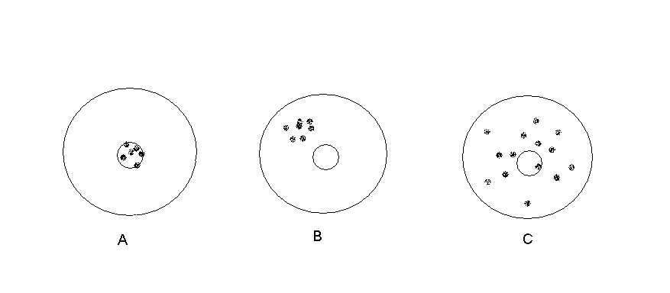

1. precision and inaccuracy
2. accuracy and imprecision
3. precision and accuracy
4. imprecision and inaccuracy

11.A qualitative, enzyme-linked immunosorbent assay (ELISA) was performed as follows:

1. Patient serum added to an antigen-coated microtiter well

2. Incubated

3. Washed

4. Horseradish peroxidase-labeled antihuman globulin added

5. Incubated

6. Peroxide and chromogen added

7. Reaction stopped

The resulting color development was extremely intense because:

A. incorrect substrate was added

B. the patient’s serum contained a large amount of antibody

C. the patient’s serum contained a small amount of antibody

D. a step in the procedure was not performed