PARTS OF THE MICROSCOPE

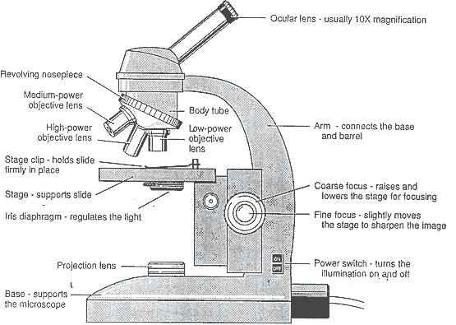

**Objective Lens**:

* Objective produces the primary image
* The oculars (eyepieces) magnify the primary image projected by the objective
* The clarity, sharpness, detail and visibility needed for good performance in microscopy depend on the quality and care of the objectives

**Condenser**:

* Mounted under the stage to concentrate and focus light from light source
* Can be raised or lowered by means of the condenser know below the stage
* Has an aperture iris diaphragm that can be opened or closed to control the amount of light striking the specimen

**Illumination:**

* A built-in light source, usually a tungsten bulb or tungsten-halogen bulb, works by plugging the microscope cord into an electrical outlet and using the on-off switch
* Adjustment of the field diaphragm on the projection lens increases or decreases the circle of light in the viewing field

**100x oil immersion objective:**

* + Focus and center the specimen with the 10x objective, followed by the 40x objective; lower the stage using the coarse adjustment knobs, with the 40x objective in the light path.
  + Place a drop of immersion oil on the coverslip of the slide being examined, directly over the light path, making certain the drop is placed so that the objective will dip into the drop when the stage is raised. Rotate the nosepiece until the 100x oil immersion objective comes into the light path.
  + Looking peripherally at stage level and not through the eyepiece, raise the stage slowly until the objective makes contact with the oil drop, causing a flash of light.
  + Raise the stage slowly using the fine adjustment knobs while looking through the eyepieces; at the slightest resistance, stop, because the coverslip may be too close (at this time, the specimen should come into focus).

After using the oil immersion objective, clean it with a piece of lens paper, dampened with lens cleaning solution. Avoid getting oil on the 40x objective. Make sure to dry the objective by either gently blowing with air or using a clean, dry sheet of lens paper