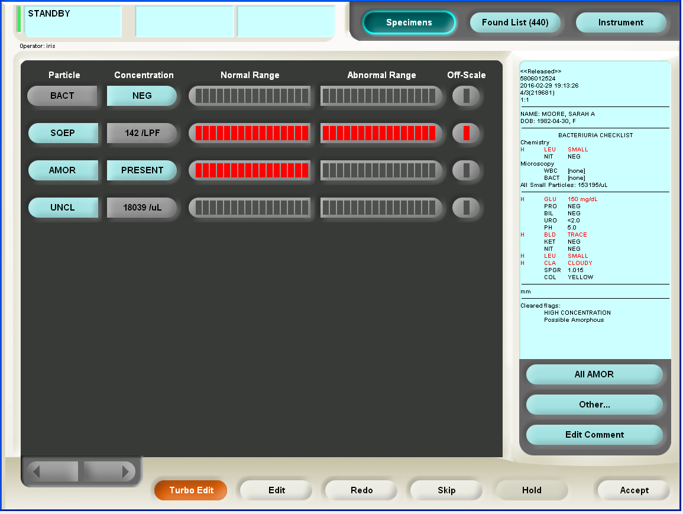

You are evaluating this urine on the iQ bench. The following is correct

1. Assuming all the editing was correct, this should be accepted and verified. No further work-up is necessary.
2. This specimen should not have been run through the iQ.
3. The clean rack (ie cleanser, diluent, diluent on iQ QC rack) should be run.
4. The dipstick results are not consistent with the iQ results, a manual micro should be performed and manual micro reported.
5. This specimen should be deleted from the work list.
6. According to the manufacturer cloudy, turbid, bloody or mucoid specimens should not be run through the analyzer undiluted.

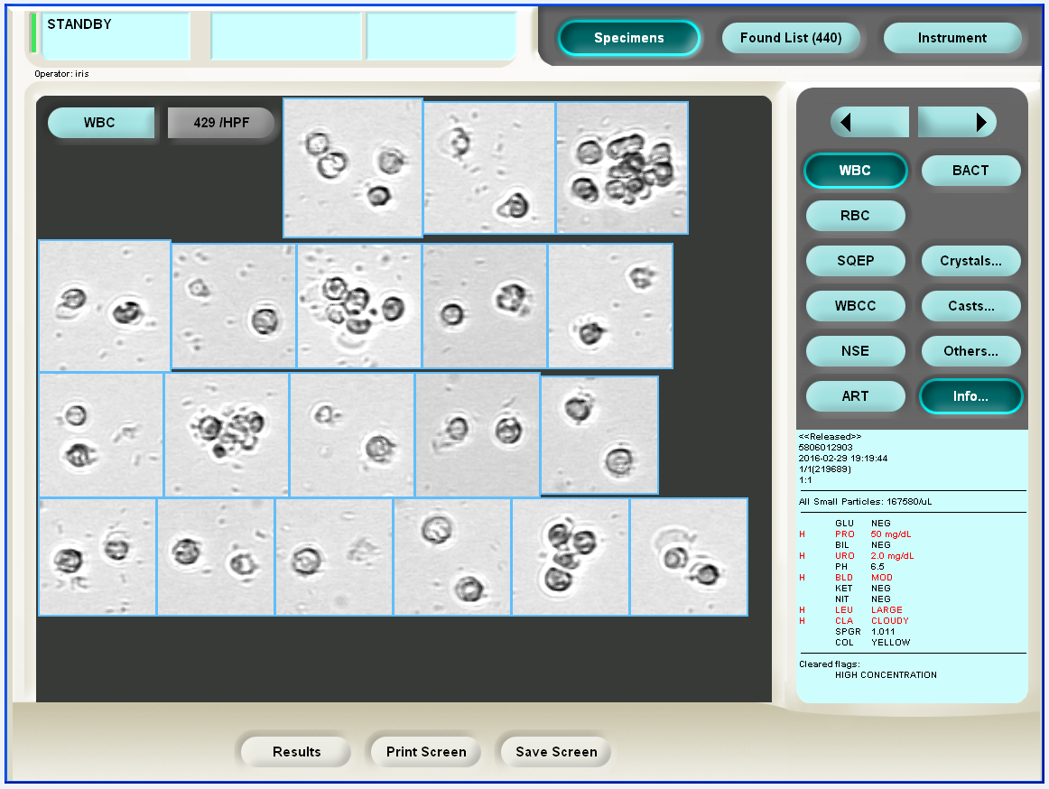

You are evaluating this urine on the iQ bench. The following is correct

1. According to the “Suggested Bacteria Grading Chart” bacteria are likely 3+ to 4+ present.
2. The ASP count may be used to advice the grading of the bacteria.
3. No obvious bacteria are present
4. Manual microscopy can be used to confirm if bacteria is present
5. ASP count suggests 2+ bacteria are present.
6. Obvious bacteria are present

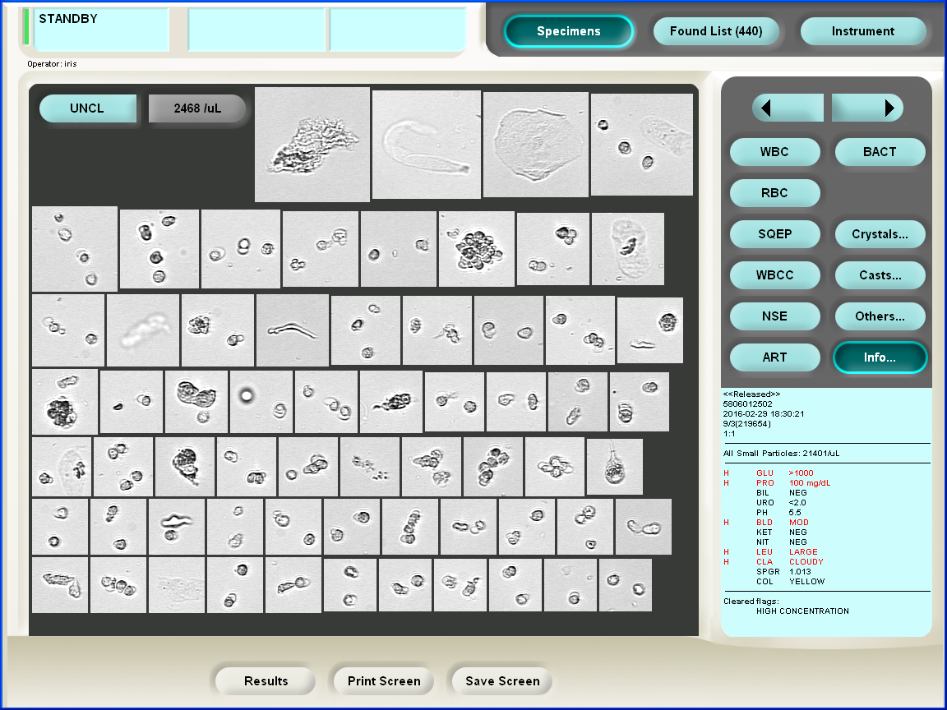

You are in UNCL editing the above urine, the following boxes should be placed into the following categories:

1. All WBC’s should be placed in the WBC category until > 183 WBC/HPF are reached.
2. The SQEP should be placed in the SQEP category until >2858/LPF are reached.
3. All hyaline casts should be placed in the HYAL category.
4. All RBC’s should be placed into the RBC category until > 183 RBC/HPF are reached.
5. All clumps of WBC’s should be placed in the WBC category until > 183 WBC/HPF are reached.
6. Any unusual findings such as waxy casts, cellular cast, cholesterol crystal, Trichomonas, Oval Fat Bodies, etc should be confirmed by manual microscopy.
7. Why is it important to pay attention to the Lamina’s number when changing Lamina Jugs? ____________________________________________________________________________________________________________
8. Where should the CLS document the corrective action required for control results outside acceptable range on every instrument, meter and/or test in UA? _________________________________________________________________________________________________________
9. When and how many Aution test strips should be added to the hopper at one time? _______________________________________________________________________________________________________________
10. A highly colored urine (assume Pyridium) is being processed and has a UAD only ordered. What are your next steps? (address how to result the UAM results, when a UAM and C UR should be performed) ____________________________________________________________________________________________________________________________________________________________________________________________________________________________________
11. When resulting a UAD with a POS Prot. and a pH of > 8, what are the next necessary steps? ________________________________________
12. Per the 2-19-13 decision of the Chiefs of Pathology, all urines that have a POS Bili that is NOT due to the color of the urine should be resulted as ______________ with a comment ________________ (template of comment).
13. After running a UAD/UAM through the AX/iQ on a 13 year old female, sperm is observed while editing the specimen on the iQ. What are the necessary next steps? ____________________________________________________________________________________________________________________________________________________________________________________________________________________________________
14. What does “ASP” refer to and what is it used for? When should the “ASP” count be disregarded or used with “caution”? __________________________________________________________________________________________________________________
15. The following categories do not transmit from iQ to RILIS so it is necessary to report manually or as a comment (circle all that applies)
16. CELL (cell casts)
17. BROAD CASTS
18. EPIC CASTS
19. CYST (cystine crystals)
20. FAT/Oval Fat Bodies

**iQ:**

1. What particles should be accounted for in UNCL? __________________________________________________________________________________________________________________
2. Motility cannot be confirmed with the iQ. If Trichomonas is suspected, specimen should be examined by slide microscopy. True or False
3. When editing the iQ, it is required to place all WBC clumps into the WBC category. True or False
4. A cloudy specimen was accidently run through the iQ. What should be done? ____________________________________________________

Microscopic Review: Q: What do you do if you the IQ200 indicates granular casts?

A: Perform review under microscope to confirm instrument reading