**Hyaluronidase dissolves crystals. Therefore untreated specimen should be used for examination of crystals. True**

**If wet mount is negative, use concentrated ie. cytospin specimen. True**

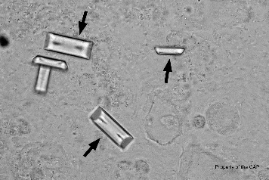

**This urine is from a 77-year-old woman**

**Laboratory data include: specific gravity=1.017; pH=6.4; glucose, protein, ketones, nitrite, and leukocyte esterase=neg, blood = pos**

**What is the object pointed to? _______________**

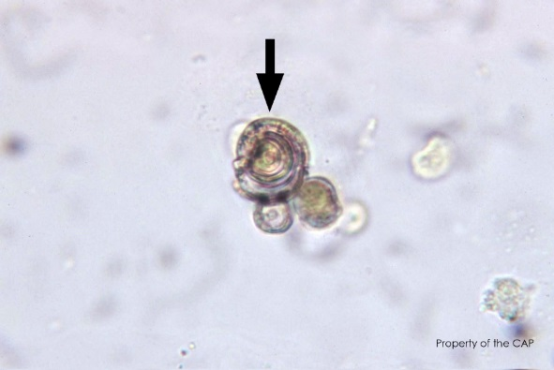

**This urine is from a 57 year old man with end stage liver cancer. Laboratory data include: specific gravity=1.045, pH=5.0, blood, leukocyte esterase and protein = positive; and glucose, ketone, and nitrite= neg**

**What is the object pointed to?** (above)_______________

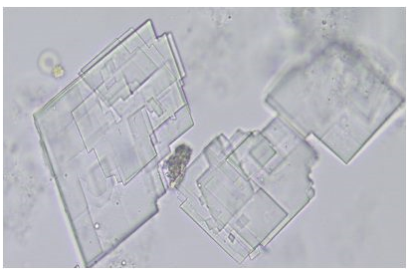

**What is the object pointed to?** (above)_______________

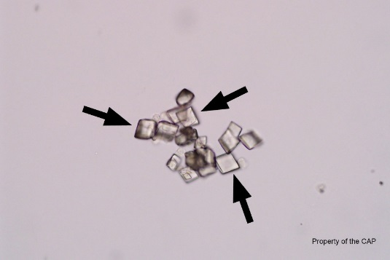

**This urine is from a 26-year-old pregnant women.**

**Laboratory date include: specific gravity=1.012, pH=5.5 glucose and ketones=neg, protein, nitrate and leukocyte esterase =pos**

**What is the object pointed to?** _______________

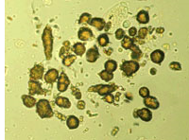

**What is the object pointed to?** _______________



This urine is from a 77-year-old woman

Laboratory data include: specific gravity=1.017; pH=6.4; glucose, protein, ketones, nitrite, and leukocyte esterase=neg, blood = pos

**CM-A 2015 Ammonium magnesium phosphate (triple phosphate)**

**n**

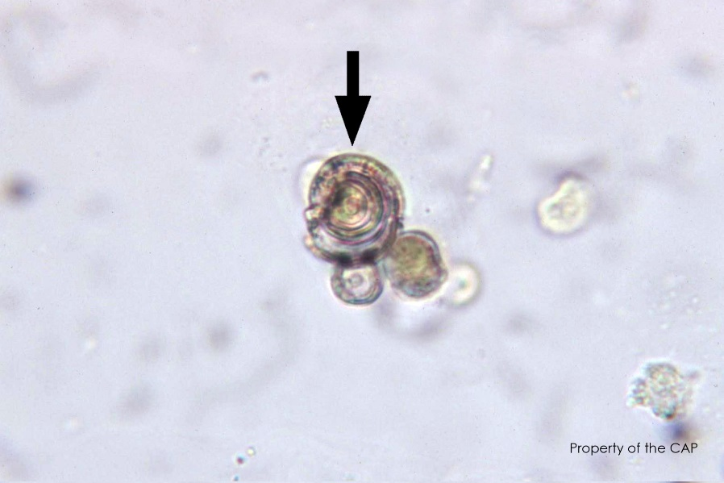

**This urine is from a 57 year old man with end stage liver cancer. Laboratory data include: specific gravity=1.045, pH=5.0, blood, leukocyte esterase and protein = positive; and glucose, ketone, and nitrite= neg. Leucine Crystal 2014 CM- B**

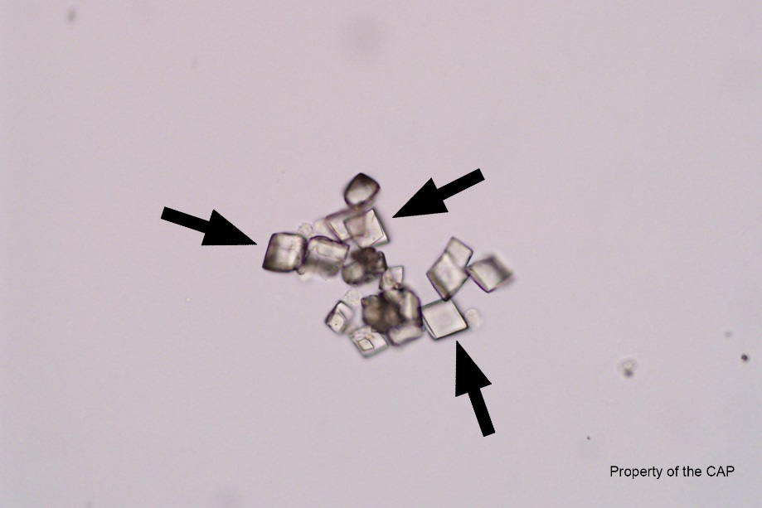

**This urine is from a 26-year-old pregnant women.**

**Laboratory date include: specific gravity=1.012, pH=5.5 glucose and ketones=neg, protein, nitrate and leukocyte esterase =pos**

**Uric acid crystal 2015 CM-B**



**Cholesterol**



**Ammonium biurate**

Ammonium biurate crystals (brown, thornapple-like spheres) are observed in portosystemic shunts and in other diseases with hyperammonemia.

1. 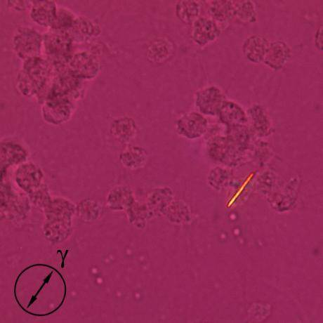This synovial fluid sample is being examined for crystals under polarized light with a red compensator in place. The direction of the slow axis of the compensator is shown by the black arrow

These crystals are:

1. Cornstarch (from surgical gloves)
2. Monosodium Urate
3. Calcium Pyrophosphate
4. Hydroxyapatite

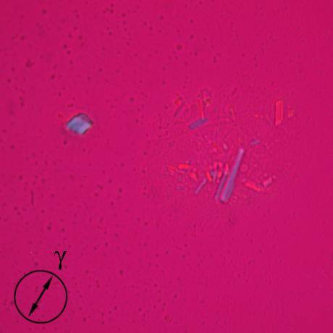

1. These crystals are:
2. Cornstarch (from surgical gloves) B
3. Monosodium Urate
4. Calcium Pyrophosphate
5. artifact

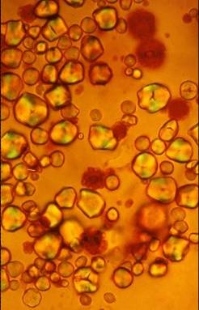

1. These crystals are:
2. Cornstarch (from surgical gloves)
3. Monosodium Urate
4. Calcium Pyrophosphate
5. Cystine