**Cholesterol Crystals –** Notice the notched corners and rhomboidal shape! They are also highly birefringent and may be associated with lipids forming Maltese cross formations.

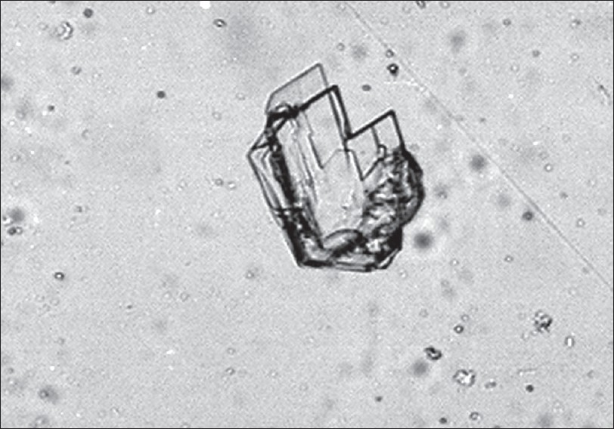

*Serous Fluid*

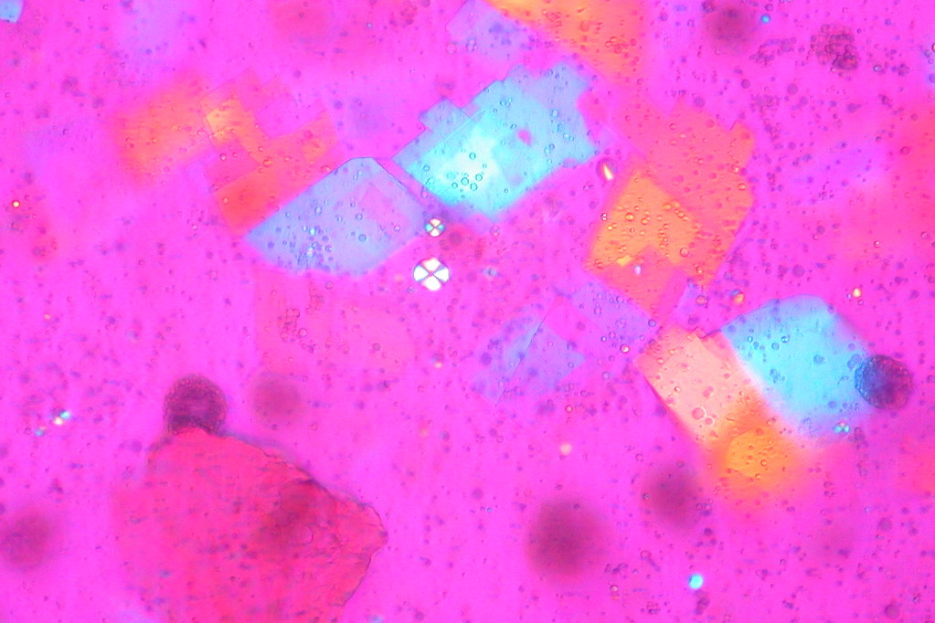

*Synovial Fluid*