BB Regional Quiz

1. A sixteen year old leukemia patient previously typed as B Pos, now front types as mixed field AB Pos, back types as AB. The patient received a bone marrow transplant from an A Neg donor. What types of red cells and FFP should be selected for transfusion of this patient?
- A Neg - to match the new Donor Blood type
- AB Neg- to match the patient but honor the Donor Rh.
- O Pos- Both A and B would be incompatible, Pos Rh is Ok.
- O Neg- Both A, B and Rh Pos would be incompatible.

2. The mother is O Pos mother and the baby is O Pos with a positive DAT.
What workup is needed?

- An ABSC on the mother and AG typing on the infant.
- Nothing, the blood types match.
- Send both out to the reference lab.
- Re-type the baby; it must be a mislabeled sample.

3. ABORh testing of an ER patient with no history shows the following:

ABORh testing from both the initial and second specimens have the same results:
Anti-A anti-B anti-D A1 cell B cells
2+MF 0 0 0 3+
(MF: mixed field)

What is the first step in trying to investigate the cause of these results?
- Re draw the patient a 3rd time
- Call the RN/ MD for the recent transfusion history of the patient.
- Send it to BloodSource.
- Re QC the reagents.

4. Which of the following is not a possible cause of Mixed Field results for a patients’ Front Type?
- Recent transfusion of a type A, B or AB person with type O blood.
- A bone marrow transplant with a different blood type.
- Poor Phlebotomy technique
- An A or B subgroup.

5. If both the initial and follow up sample show gross hemolosys, even with the best phlebotomy technique, then the possibility of a hemolytic transfusion reaction must be suspected and investigated in the recently transfused patient.
- True
- False

6.
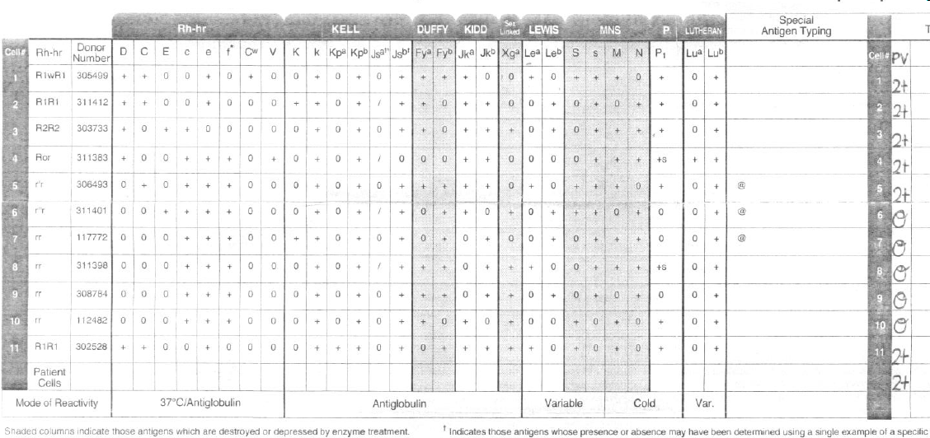

What is the likely Antibody (s) identified above? (Pick all that are correct)
- Anti-c
- Anti-D
- Anti-C
- Anti-Jkb

7. If an Rh Negative patient was transfused with only Rh negative PRBCs but the ABSC now shows Anti-D and Anti-C, which of the following is the likely antibody?
- Anti-f
- Anti-Cw
- Anti-G
- Anti-V

8. During a Positive DAT workup on an O Pos infant born to an O Pos mother the ABSC for the mother was found to be negative. This is the third child born to the couple and the second child also had Jaundice although not as severe as the current baby. What should be done next?
- Nothing the workup came out negative.
- Run an ABID panel on the mother which contains a Cw positive cell.
- Tell the MD to transfer the baby to Roseville.
- Redraw the mother.

9. Which of the following antibodies would not be expected to fade with time.
- An anti-D due to RHIG
- Anti-Jka
- Anti-Lea
- Anti-k

10. A non-clinically significant antibody would be?
- Anti-M
- Anti-G
- Anti-Fyb
- Anti-e

