Annual Competency Quiz – March
- True or False: Background check must be completed on the XT analyzer before performing the body fluid count on the XT analyzer. Background count limits for the analysis of body fluids are:
XT - WBC – 0.00
RBC – 0.00

- True
- False

- True or False: Body fluid specimens are concentrated using cytocentrifugation , which allows evaluation of fluids with low cell counts and preserves cytological detail.
- True
- False
- Synovial fluid. Identify the crytals.
- Uric Acid
- CPPD
- Cholesterol
- Artifacts
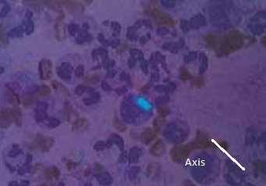

- EST is meausred ib:
- Millimeters (mm)
- Milliters (ml)
- Milligrams (mg)
- None of the above
- True or False: All counts are performed in duplicate by counting both sides of the hemocytometer.
Counts must agree within ± 10% or ± 10 cells on lower counts (<100/mcL). Counts obtained on
each side of the chamber should be recorded on the manual worksheet.

- True

- False

