Body Fluid Crystals Competency 2019

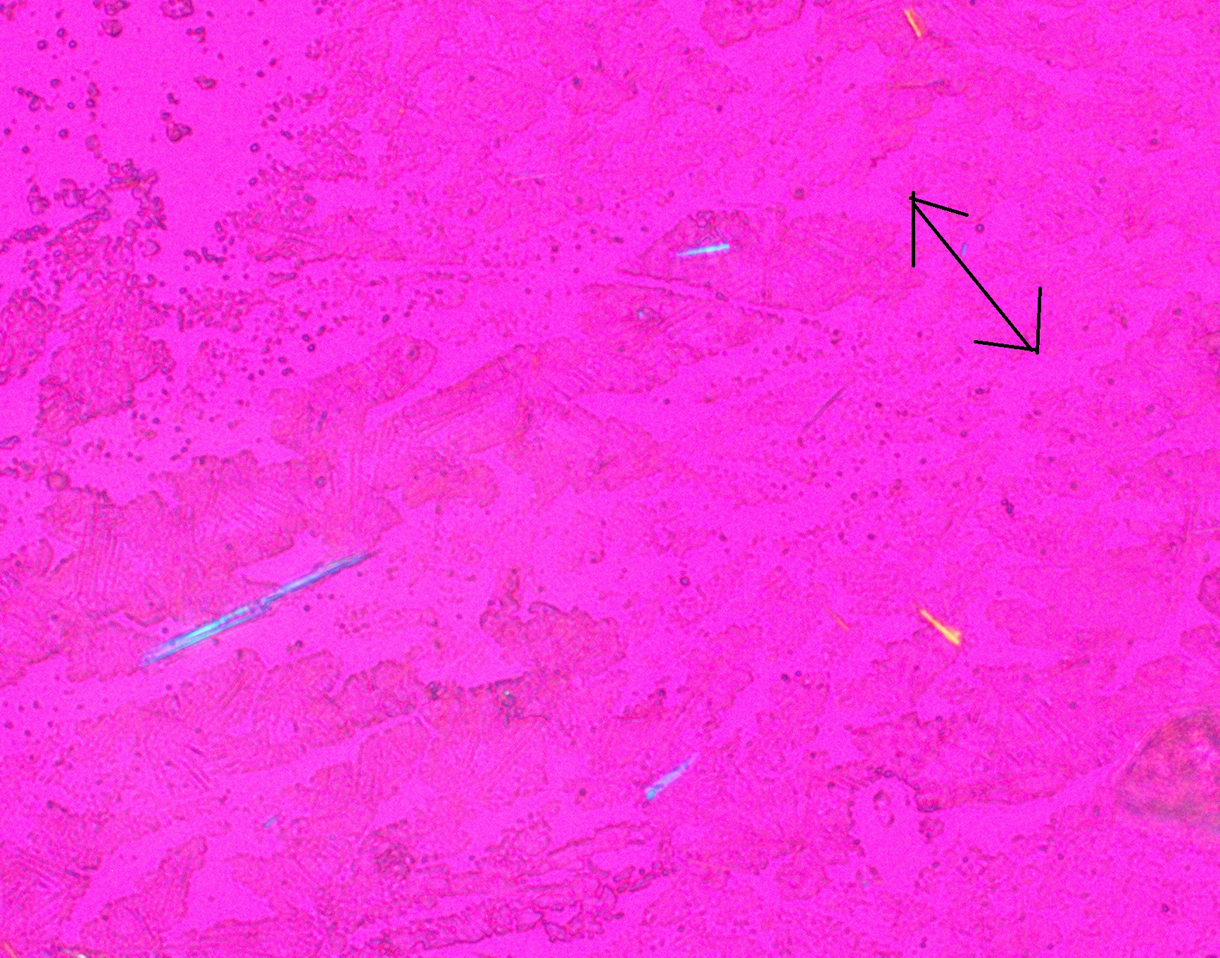

1. Synovial fluid – Identify the crystals present. The arrow represents the direction of the compensator.
   1. Artifact
   2. CPPD
   3. **Uric Acid**
   4. Cholesterol

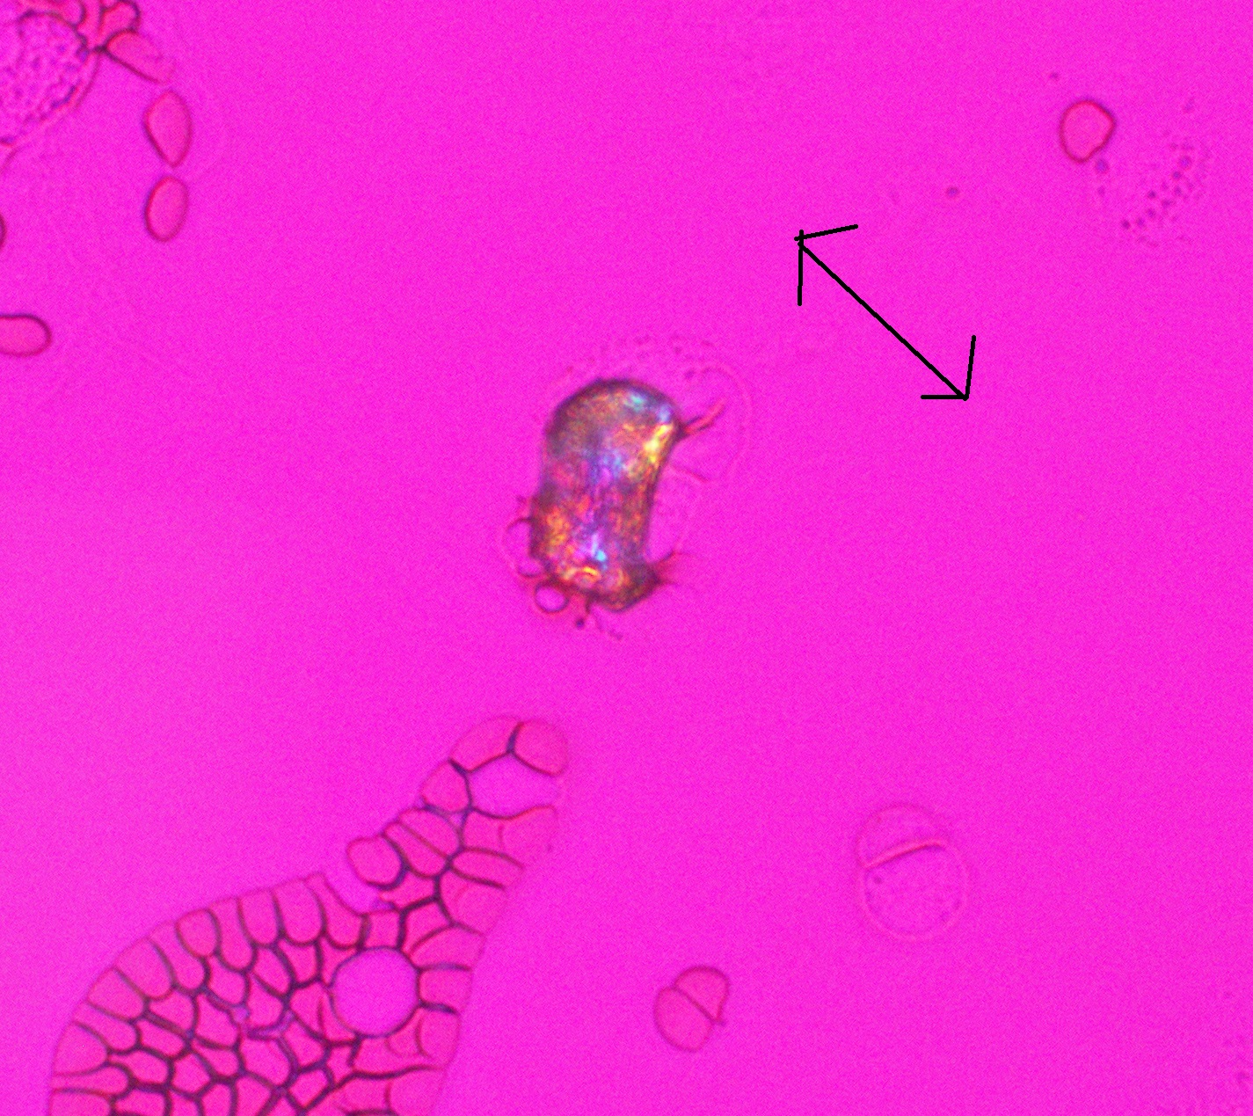

2. Synovial fluid – Identify the crystals present.

* 1. **Artifact**
  2. CPPD
  3. Uric Acid
  4. Cholesterol

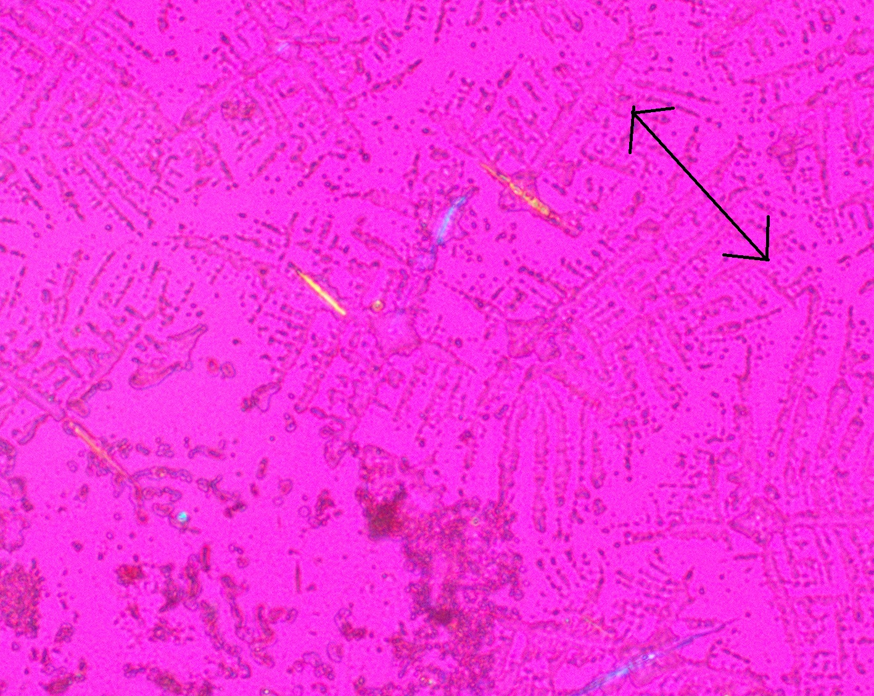

3. Synovial fluid – Identify the crystals present.

* 1. Artifact
  2. CPPD
  3. **Uric Acid**
  4. Cholesterol

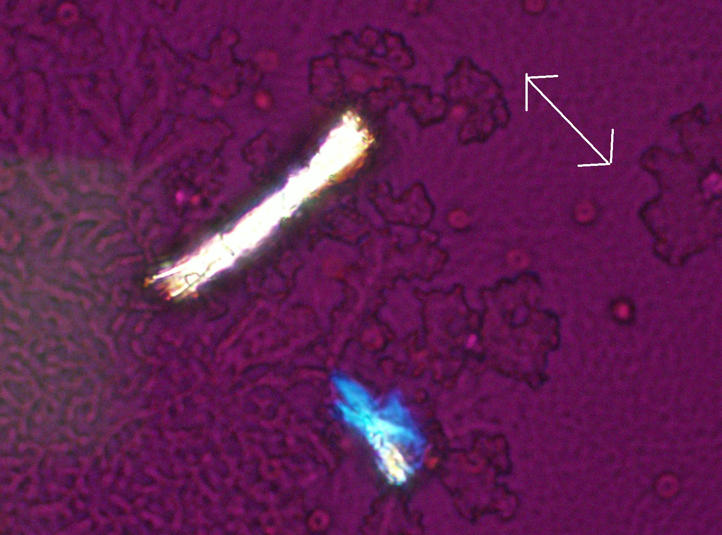

4. Synovial fluid – Identify the crystals present.

* 1. **Artifact**
  2. CPPD
  3. Uric Acid
  4. Cholesterol

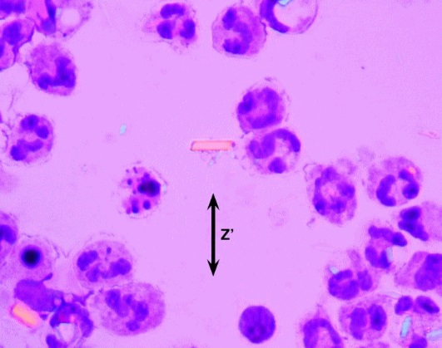

5. Synovial fluid – Identify the crystals present.

1. Artifact
2. **CPPD**
3. Uric Acid
4. Cholesterol

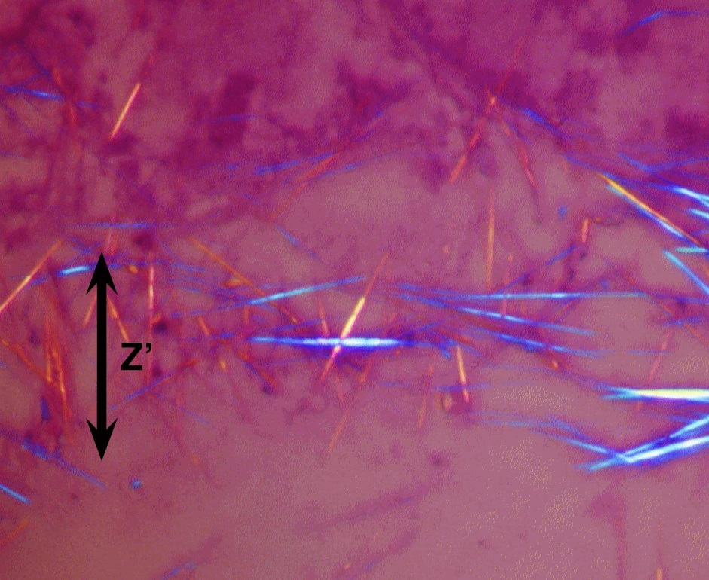

6. Synovial fluid – Identify the crystals present.

1. Artifact
2. CPPD
3. **Uric Acid**
4. Cholesterol

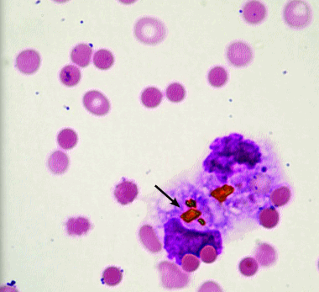

7. CSF, 45 year old female, post traumatic head injury – Identify the crystals present.

1. Artifact
2. CPPD
3. Uric Acid
4. **Hematin / hematoidin –**

Explanation: Typically seen as a yellow-orange rhomboid, hematin / hematoidin crystals are associated with prior hemorrhage. It is intensely birefringent with polarized light. They may appear intra- or extracellular. Potential look-alikes include rhomboid forms of CPPD, bilirubin, starch granules, and other debris. (from Color Atlas of Body fluids, CAP, 2006; Image from API.)