What is the first thing you should do when you find that an incorrect result has been accepted?
B-Notify the ordering physician, office, or location
A-Correct the result in MEM
C-Complete an episode report

What did the tech do wrong?
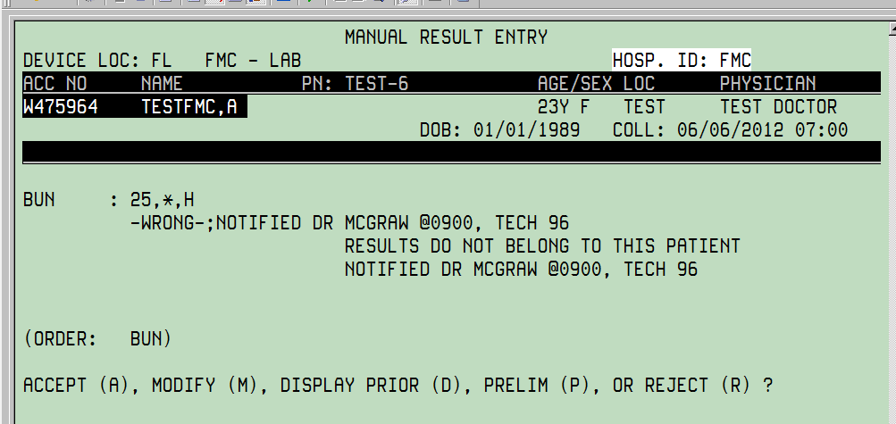
C-Used a hyphen
B-Didn’t add the correction statement
A-Used their tech code not initials

What should you do if a result was accepted on the wrong patient but a specimen for the right patient is available?
A-Run the right specimen & accept the result on the original accession number
B-Replace the wrong result with the code WRONG & reorder the test.
C-Credit (CR) the wrong result & reorder the test

What is the best thing to do if the correct result is not available?
C-Replace the wrong result with the appropriate code & credit the test in CRW
A-Append a free text (-;) to the wrong result & credit the test in CRW
B-Credit (CR) the wrong result but don’t reorder the test until the patient is redrawn

Which of the following is the best way to document provider notification?
A--; notified Dr McGraw, 5/6 @ 1500, tech 96
B-; notified Dr McGraw-;5/6 @1500, tech 96
C--;notified floor, 5/6 @1500, tech 96

