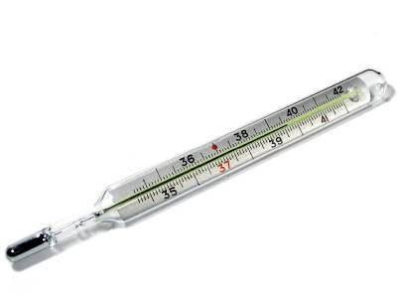



**-20**

**-30**

**-40**

**-10**

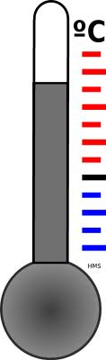

**2**

**4**

**6**

[](http://www.google.com/imgres?q=thermometer+clip+art&hl=en&biw=1680&bih=867&tbm=isch&tbnid=0S-eBaFcQ5Os5M:&imgrefurl=http://www.brrsd.net/web/adamsville/cool%20sites2.htm&docid=7JLsV9OsAdLTuM&imgurl=http://www.brrsd.net/web/adamsville/thermometer%20clipart-blank.gif&w=686&h=2146&ei=8-UjUf3gHqmwigLBs4CIDA&zoom=1&iact=hc&vpx=848&vpy=64&dur=13015&hovh=397&hovw=127&tx=93&ty=256&sig=114812826861618659575&page=1&tbnh=148&tbnw=47&start=0&ndsp=61&ved=1t:429,i:174)