[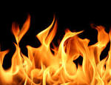](http://www.google.com/url?url=http://dreamatico.com/fire.html&rct=j&frm=1&q=&esrc=s&sa=U&ved=0CBgQwW4wAWoVChMIqb7wnN2mxwIVhJSICh26Ewsn&usg=AFQjCNG0OgDMYZd4rdd-wAXwzYrXui6i8A)[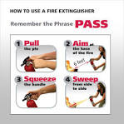](http://www.google.com/url?url=http://www.amazon.com/Kidde-466141-Kitchen-Garage-Extinguisher/dp/B001AYEREU&rct=j&frm=1&q=&esrc=s&sa=U&ved=0CBoQwW4wAmoVChMI4a3Jst2mxwIVgjiICh1SkQ1p&usg=AFQjCNGE9z-NZ2lhClrlpb7xRXdHpHR67w)[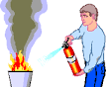](http://www.google.com/url?url=http://www.bradford-co-fla.org/scvfd/extinguisher.html&rct=j&frm=1&q=&esrc=s&sa=U&ved=0CBwQwW4wA2oVChMI4a3Jst2mxwIVgjiICh1SkQ1p&usg=AFQjCNHSY6ZPBsmlgEZyABA8FZ4Z2Gc5Cw)

[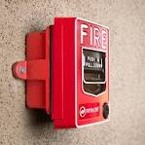](http://www.google.com/url?url=http://www.firedepartment.org/fire_prevention/unwarranted_fire_alarms.asp&rct=j&frm=1&q=&esrc=s&sa=U&ved=0CBwQwW4wA2oVChMIt8aNgeKmxwIVyFaICh0bxAAI&usg=AFQjCNHoDw-nXRZSTRlsbhDqbfisnmCTKQ)