CHEMISTRY COMPETENCY 2013

1. Which of the following statements about Hepatitis B virus (HBV) is/are correct? (Choose all that are true)

* People who carry HBV often have no symptoms
* HBV is spread through unsafe injection practices and needle stick injuries
* Most infants born to mothers who are carriers of HBV are at risk of being infected
* A chronic carrier of HBV is more likely to develop liver disease later in life
* **All of the above**



1. A liver profile has the following results: ALT = 250, AST = 250, Alk P = 200, GGT = 350, T Bili = 5.0, D Bili = 2.5, Total Protein and Albumin are normal

Which of the following disease states most fits these results?

* Acute Hepatitis B
* Hemolysis in vivo
* Acute Tylenol (Acetaminophen) overdose
* **Possible liver tumor**

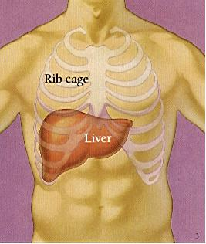

1. Why is Sodium written as Na instead of So, and Potassium written as K instead of Po?

ANSWER: **The Latin names are Natrium and Kalium**

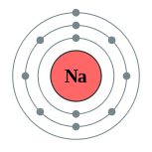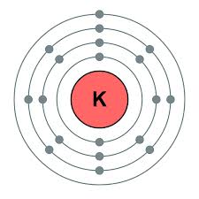

1. Why would a provider ask us to dilute a prolactin 1:1000, even though we’ve already reported a normal result of 10?

* **The provider is concerned that the result is extraordinarily high, and we missed it due to prozoning**.
* **The patient’s CT scan noted a large mass on the pituitary**
* The patient had a very high AFP
* Both A and B are correct

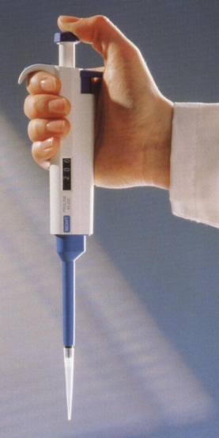

1. If the triglyceride QC is completely out of range, it could be due to:

* The Trig R1 mix was not poured into the reagent wedge
* The L1 and L2 control cups were mixed up
* The reagent bottle is almost empty
* **All of the above**

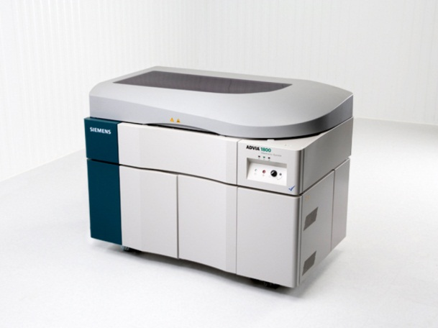

1. What is the proper way to mix the reconstituted calibrators and controls in Chemistry?

* Shake vigorously
* Invert 20 times quickly
* Vortex
* **Let the reconstituted vials sit 20-30 minutes to equilibrate, then *gently* rotate the vials between your palms**

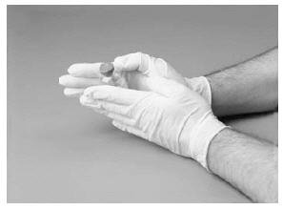

1. If you have 2 consecutive QC points 2-3 SD, do you need to investigate?  **Yes** No
2. What are some actions you might take to resolve question #7?

* Review the Levy-Jennings graphs for shifts and/or trends
* Check the open date and the volume of control material
* Repeat the control (once) to rule out random error
* Make and run a new bottle of control
* **All of the above**

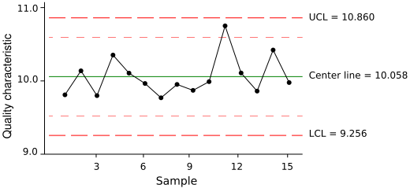

1. When you result a positive Hepatitis or HIV, (pick the true statement)

* **Orders are automatically generated for state lab confirmation**
* We have to write up paper orders

1. How many days du we hold serum tubes? ____**6**______
2. How long is a serum sample stable for an add-on B12 Folate?

* 8 hours
* 24 hours
* **48 hours**
* 1 week

1. How might you be able to tell if a purple top was drawn in error, then immediately put into a red top tube instead of re-drawing?

* **The Ca will be extremely low and the K will be high**
* The plasma will have a slight purple color
* The Ca will be extremely high and the K will be low
* The sample will never clot

