**COAGULATION COMPETENCY 2013**

**In the formula used to calculate international normalized ratios (INRs), what does the *ISI* represent?**

|  |
| --- |
| The patient’s prothrombin time reported in seconds |
| The prothrombin time for the normal control reported in seconds |
| **A measure of a thromboplastin reagent’s sensitivity performance in the PT assay** |
| A method verification code for the thromboplastin reagent |

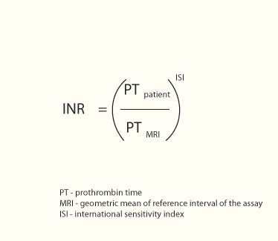

**According to CLIA, what is the minimum number of levels of control materials, and how often must each of these control materials be run on an automated coagulation test system?**

|  |
| --- |
| One level tested every 2 hours and each time a reagent is changed |
| One level tested every 6 hours and each time a reagent is changed |
| **Two levels tested every 8 hours and each time a reagent is changed** |
| Two levels tested every 12 hours and each time a reagent is changed |

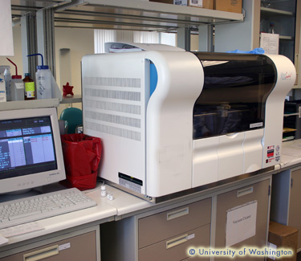

### A PT and PTT were performed on the sample shown in the picture. What results should be expected in this case?

|  |
| --- |
| Clotting times will be falsely shortened |
| Clotting times will be within reference range |
| **Clotting times will be falsely prolonged** |

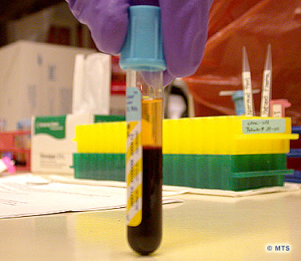

### What might cause a prolonged Prothrombin Time?

|  |
| --- |
| Bivalirudin therapy (Bivalirudin is a Direct Thrombin Inhibitor) |
| Coumadin Therapy |
| Very High concentration of Heparin in the sample (>10 U/mL) |
| Vitamin K deficiency |
| **All of the above** |

### http://medtraining.org/ltac3/account/media/2012-2/coag02.jpg The letters INR in the Prothrombin time assay stand for:

|  |
| --- |
| Incident of Normalization Rate |
| International and National Ratio |
| **International Normalizing Ratio** |
| Internal Negative Reduction |

