[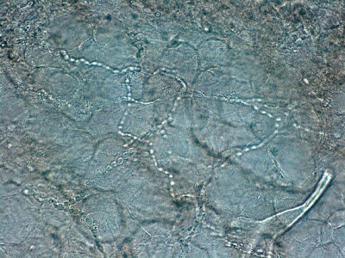](http://3.bp.blogspot.com/-BmDLqNj1j2M/T0lggZvWztI/AAAAAAAAG_s/H9q6XUBUYTU/s1600/03-+Trichphyton+rubrum+Infected+Nail+%28KOH%29+1.jpg) Trichphyton rubrum (nail)

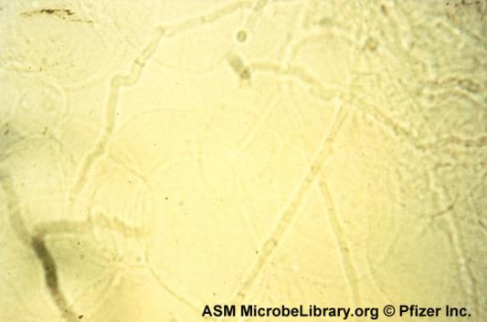Dermatophytes

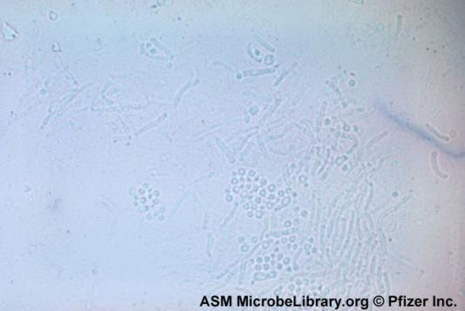tinea versicolor infection with P. ovale cutaneous infection (spaghetti and meatballs)m skin scraping

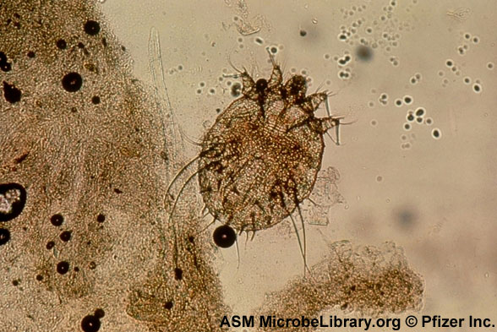Scabies mite koh skin scrarping low power