[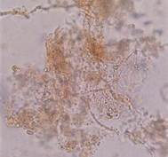](http://www.bing.com/images/search?q=Koh+Skin+Scraping&FORM=RESTAB#view=detail&id=DC2A079DE5C8FBD46740C4F49F50ECCC9576BEEB&selectedIndex=5)Positive KOH Prep(SKIN)

[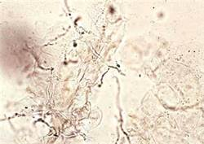](http://www.bing.com/images/search?q=Koh+Skin+Scraping&FORM=RESTAB#view=detail&id=91FF46567C18C72CE7CAC5A4ED0658EFBFD871CB&selectedIndex=8)Positive KOH (SKIN)

[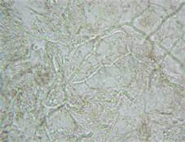](http://www.bing.com/images/search?q=Koh+Skin+Scraping&FORM=RESTAB#view=detail&id=F06D0B3DB091C9151EF036351FC5D579D9806AE6&selectedIndex=10) Positive KOH (SKIN)

[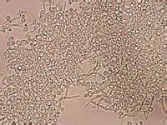](http://www.bing.com/images/search?q=Koh+Skin+Prep&FORM=RESTAB#view=detail&id=00CDC9F1FC2DA55C07D9D83D7721455639C7923C&selectedIndex=8) Positive KOH (SKIN)

[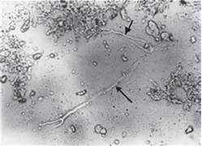](http://www.bing.com/images/search?q=Koh+Preparation+For+Fungal&FORM=RESTAB#view=detail&id=1CA85F8D5CA34FE4456E4A109011C77CE1331DF8&selectedIndex=3) Positive KOH (SKIN)

[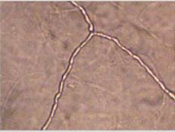](http://www.bing.com/images/search?q=koh+prep+for+nail+fungus&qs=IM&form=QBIR&pq=koh+prep&sc=8-8&sp=4&sk=HS2IM1#view=detail&id=7C69FFE010245DAA27A06431F31762CFD6A67CD9&selectedIndex=3)toenail

[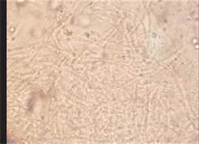](http://www.bing.com/images/search?q=koh+prep+for+nail+fungus&qs=IM&form=QBIR&pq=koh+prep&sc=8-8&sp=4&sk=HS2IM1#view=detail&id=F06D0B3DB091C9151EF0EF8F4E3E880C4B3DE738&selectedIndex=13)nail

[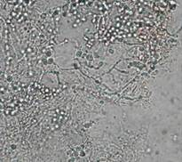](http://www.bing.com/images/search?q=koh+prep+for+nail+fungus&qs=IM&form=QBIR&pq=koh+prep&sc=8-8&sp=4&sk=HS2IM1#view=detail&id=D0B1CF7D4778013A20A7C0D9E0349786FFE8229C&selectedIndex=25)nail

[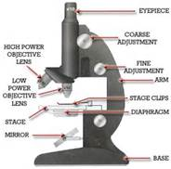](http://www.bing.com/images/search?q=Microscope+Diagram&Form=INRRLS#view=detail&id=16F38CBE79639C0A6DB02ACE086F98C2898F2013&selectedIndex=12)

[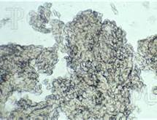](http://www.bing.com/images/search?q=dermatology+microsope+pics&qs=n&form=QBIR&pq=dermatology+microsope+pics&sc=0-19&sp=-1&sk=#view=detail&id=9AB8D5EE6945B1460F6BC26996816ABAD7D10AF0&selectedIndex=121)Negative Skin KOH

[](http://www.bing.com/images/search?q=college+of+american+pathologists+proficiency&qs=AS&sk=IM1SS1AS1&FORM=QBIR&pq=college%20of%20america&sc=8-18&sp=4&qs=AS&sk=IM1SS1AS1#view=detail&id=C277195BA73D7D3B886A1EB5256E3B61706BAB25&selectedIndex=101) [](http://www.bing.com/images/search?q=college+of+american+pathologists+proficiency&qs=AS&sk=IM1SS1AS1&FORM=QBIR&pq=college%20of%20america&sc=8-18&sp=4&qs=AS&sk=IM1SS1AS1#view=detail&id=E760EF036F07370EAE1763EE92EF11E84976D210&selectedIndex=314)