Question # 1

A patient came to the emergency room with symptoms of a fever and a rash. This is the gram stain of the CSF.

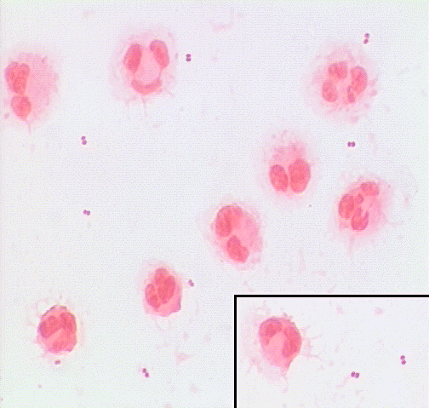

What is the Gram stain morphology of the organism seen?

a. Gram positive cocci in pairs

b. Gram negative rods

c. Gram negative diplococci

d. Gram positive rods

Question # 2

What is the expected pathogen on the above image?

a. Neisseria sp.

b. Cryptococcus sp.

c. Listeria sp.

d. Haemophilus sp.

Question # 3

After confirmation and the normal reporting process to the provider, what are the next steps?

a. Call Infection Prevention

b. Tape plates

c. No additional action needed

d. Both A and B

Question # 4

It is important to review a respiratory smear at 10x before changing to 100x to look for bacteria and fungus.

a. True

b. False

Question # 5

W:\Microbiology\Pictures\S7833002-4.tif

What kind of bacteria are seen in this abdominal fluid?

a. Gram negative bacilli with capsules and Gram positive rods

b. Gram negative bacilli only

c. Gram positive cocci and Gram positive bacilli

d. Gram positive bacilli and overdecolorized gram positive bacilli

Question # 6

W:\Microbiology\Pictures\2018\X6987463 - Yeast in CSF.tif

This is a CSF Gram stain from an immunocompromised patient.

What would the expected pathogen be?

a. Neisseria meningitididis

b. Cryptococcus species

c. Haemophilus species

d. Streptococcus pneumoniae

Question # 7

What would the expected CSF protein and glucose be?

a. Protein high and glucose high

b. Protein high and glucose low

c. Protein low and glucose high

d. Protein low and glucose low

e. Both would be within the normal range

Question # 8 This is a gram stain from the inside of the mouth. What is the arrow pointing to?

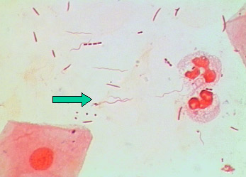

a. Gram negative bacilli

b. Artifacts

c. Spirochetes

d. Parasites

Question # 9



What is the correct way to report this gram stain from an oral abscess?

1. Few polymorphonuclear cells

Rare epithelial cells

Many gram positive cocci

2. Polymorphonuclear cells Few

No organisms seen

Alert Comment added

3. Few polymorphonuclear cells

Rare epithelial cells

No organisms seen

4. Many gram positive cocci in clusters suggestive of Staphylococcus

Few polymorphonuclear cells

PVND and alert comment

Question #10

Sputum codes are not used on patients of a certain age on the RTCS. What is the age where all organisms are

reported in the gram stain?

1. Patients less than 5 years of age

2. Patients less than 6 months of age

3. Patients less than 2 years of age