[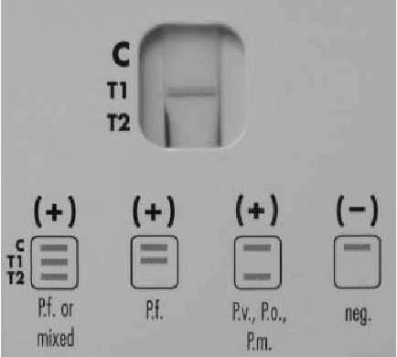](https://www.google.com/url?sa=i&rct=j&q=&esrc=s&source=images&cd=&ved=2ahUKEwjwxaqc66XkAhV-GDQIHcL_Ak8QjRx6BAgBEAQ&url=https%3A%2F%2Fwww.semanticscholar.org%2Fpaper%2FInvalid-result-of-Plasmodium-falciparum-malaria-the-Durand-Faure%2Ffbf1865fec95560c2eaf5043cca8bd85236beaef&psig=AOvVaw3_f4VCAx8C3FtOUqifMysk&ust=1567091041730420)