1. You suspect you may have over-decolorized the Gram stain slide seen in this image. What would be the appropriate next steps?

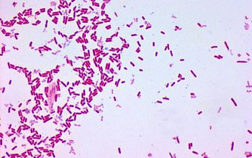

1. Report “Gram positive bacilli” and send to Central lab for review (if applicable).
2. Report “Gram negative bacilli” and send to Central lab for review (if applicable).
3. Remake and re-stain the slide to confirm. Do a remote review if possible or send to Central lab to confirm (if applicable) if decolorization is still in question.
4. No additional steps needed, report as seen.
5. This image is from a sterile fluid Gram stain prepared by cytospin. Assuming there are clear polymorphonuclear cells elsewhere on the slide, how should this stain be reported?

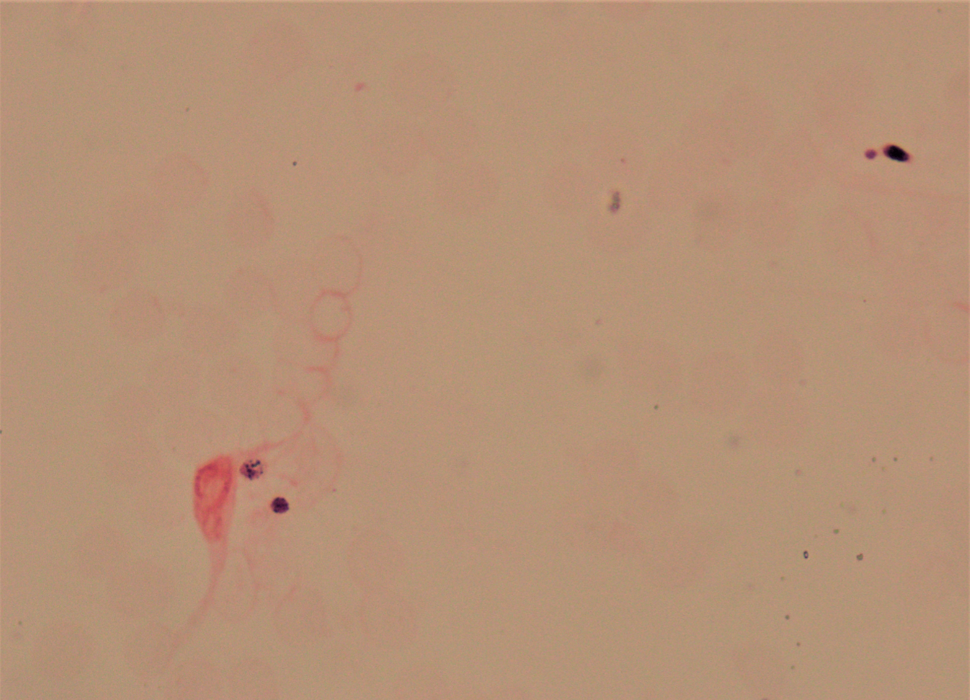

1. Present polymorphonuclear cells, Present Gram negative bacilli
2. Present polymorphonuclear cells, Present yeast, CSPIN
3. Present polymorphonuclear cells, Present Gram positive cocci, CSPIN
4. Present polymorphonuclear cells, No organisms seen, CSPIN

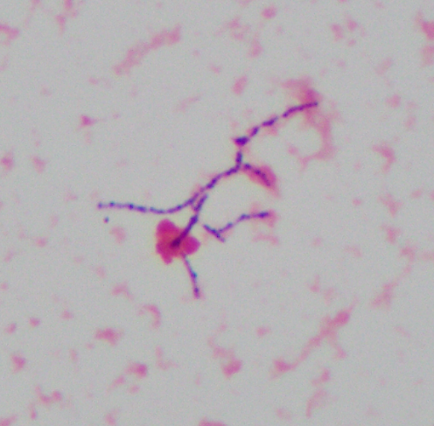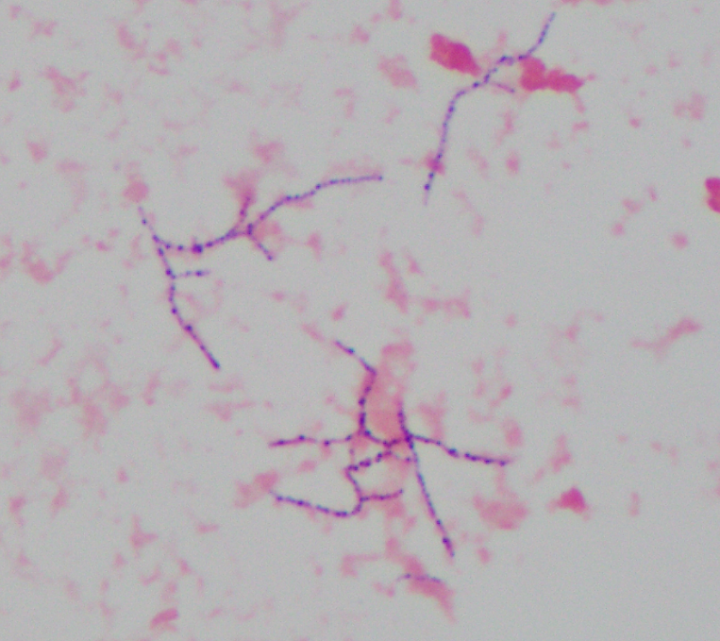

1. Both images are 100X. What structures are present on this Gram stain?
2. Fungal hyphae
3. Gram positive cocci in chains
4. Branching Gram positive rods
5. Gram positive diphtheroid-like bacilli
6. This Gram stain slide is from a pleural fluid that was cytospun. How should the organism be reported?
7. Rare fungal hyphae, CSPIN
8. Few Gram positive cocci in chains, CSPIN
9. Present Gram positive diphtheroid-like bacilli, CSPIN
10. Present branching Gram positive rods, CSPIN
11. Remote review was not working, and it was decided to send the slide to Central for review.

What comment needs to be added to the Gram stain result prior to prelim verifying it?

1. “Preliminary Report to be Reviewed by ACL Central” (MCPRE)
2. No comment is needed because a preliminary Gram stain result shouldn’t be released before review at Central
3. “Gram stain confirmed by ACL Central” (MCGRAM).
4. “Upon Review by ACL Central” (MCREV)
5. The paperwork that is required to accompany all Gram stains submitted for review is available in PolicyTech and is called- *MICRO REQUEST FORM FOR SLIDE REVIEW TO THE CENTRAL LAB (Beaker)*

a. True

b. False

1. What is the morphology of the organism in this image of a Gram stain from an abdominal aerobic culture?
2. 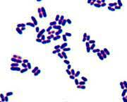Gram positive cocci in pairs
3. Gram positive cocci
4. Gram positive bacilli
5. Under-decolorized Gram negative bacilli

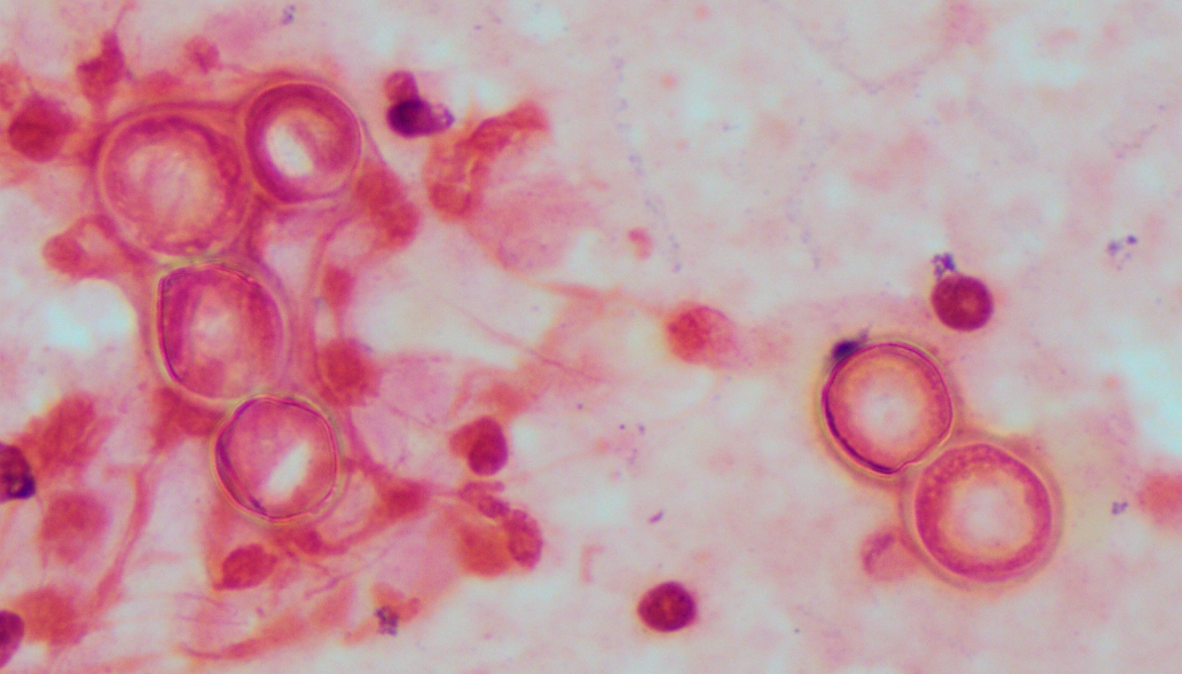

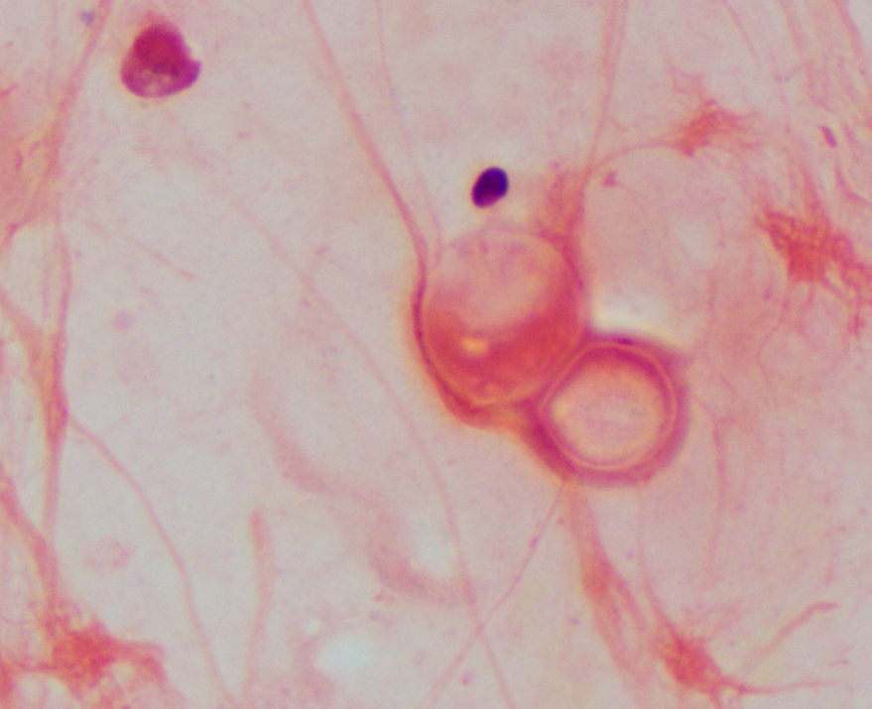

1. Both images are 100x from a sputum Gram stain? What structures are highlighted in these Gram stains?
2. Monocytes
3. Red blood cells
4. Fungal spores
5. Yeast
6. If these are the only structures seen in this sputum Gram stain, how should they be reported?
7. Many monocytes
8. Present yeast
9. Few red blood cells
10. Present fungal spores
11. If Central lab is contacted to confirm the identification of these structures by remote review, what program should be utilized?
12. Skype
13. Zoom
14. Microsoft Teams
15. None of the above
16. If the gram stain remote review icon isn’t located on the PC, how else can you share your screen and have a slide remote reviewed?
17. Search for the “Gram stain camera meeting” on the Teams app
18. Use Skype instead
19. If the icon is missing, a remote review can’t be done
20. Take images with your phone and email them to Central
21. When reading a sputum Gram stain from an adult inpatient, the technologist notices that the specimen has many epithelial cells and rare polymorphonuclear cells. How does the technologist proceed? Choose the response that is NOT part of the appropriate workflow.
    1. Enter “culture not performed” as the culture result.
    2. Result the Gram stain using the BSPT code.
    3. Notify the physician/floor that the sputum culture will be cancelled and request re-collection.
    4. Wait for the Central lab to final the culture.
    5. Final the culture.
22. When examining a sputum Gram stain from a patient < 6 months old, the Gram stain should be read as a bronchial specimen.
23. True
24. False
25. When examining a Gram stain from an abdominal fluid, the technologist observes many polymorphonuclear cells, no epithelial cells, moderate Gram positive cocci, and few Gram negative bacilli. How does the technologist proceed with reporting?
26. Do not report the epithelial cells since they are not present.
27. Ask a second tech to review the Gram stain before reporting.
28. Report the Gram stain result and notify the physician/floor of the significant result.
29. Report the Gram stain result.
30. A remote review is performed, a consensus is reached between the RRL and Central lab that the organism seen should be reported as Gram negative coccobacilli. Who is responsible for entering this result in the LIS?
31. The RRL tech requesting the review.
32. The Central lab tech performing the review.
33. A supervisor must be notified to enter the result.
34. What is the correct order of operations for performing a remote review?
35. Read smear, call central lab, get camera ready on Teams, review
36. Call central lab, read smear, get camera ready on Teams, review
37. Read smear, get camera ready on Teams, review, call Central lab
38. Read smear, get camera ready on Teams, call Central lab, review
39. A sputum culture Gram stain shows few epithelial cells, moderate polymorphonuclear cells, moderate Gram positive cocci in clusters, moderate Gram positive cocci in chains, moderate Gram negative bacilli. How do you report this?
40. GSPUTA; Moderate Gram positive cocci
41. GSPUTA; Moderate Gram positive cocci in clusters and chains
42. GSPUTB
43. BSPT
44. A sputum culture Gram stain shows rare epithelial cells, many polymorphonuclear cells, and many budding yeast with pseudo hyphae. How do you report this?
45. GSPUTN; yeast
46. GSPUTB
47. GSPUTA; Present yeast
48. GSPUTA; Many yeast
49. A pericardial fluid Gram stain shows three Gram negative bacilli. You stain a second slide and bacteria is seen in the second slide. How do you proceed?
50. Report the presence of Gram negative bacilli as “Rare” and release the results.
51. Do not release any results. Send stained slide to Central Micro Lab with “Request Form for Slide Review to the Central Lab” to review and release results.
52. Have second tech review the slides and confirm presence of Gram-negative bacilli, release “Rare Gram negative bacilli”.
53. Report the presence of Gram negative bacilli as “Rare” with comment “MCPRE”. Complete the “Request Form for Slide Review to the Central Lab.” Send stained slide and Slide Review form to Central Micro Lab for confirmation of results.
54. Report as no organisms seem.
55. Slides sent for review by Central Lab that show discrepant results will be kept by the Central Lab and saved for seven days.

a. True

b. False

1. When reviewing a slide from an RRL at Central lab, discrepant results are communicated to the site that read the smear. Which of the following is not considered a discrepant result?
2. Quantitation of organisms reported within one quantity
3. Difference in Gram reaction
4. Presence or absence of organisms reported
5. Difference in Gram morphology

22. A CSF Gram stain with no organisms seen must send the original smear for review by the Central Lab, along with an unstained slide, if it meets the following criteria:

* 1. The CSF WBC cell count is >10 cells per cm
  2. Polymorphonuclear cells are seen in the Gram stain, regardless if there are additional lab tests (WBC cell count, glucose, and protein) available or not
  3. If there are no polymorphonuclear cells seen, but the CSF protein is elevated, and the CSF glucose is decreased.
  4. All of the above