Part A: Autofluorescence Smear for Cyclospora and Isospora/Cystoisospora
- Oocysts under UV microscopy: autofluorescence positive, spherical, 7.5-10 µm.
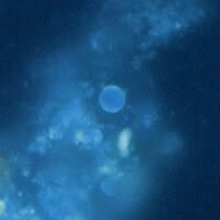 | 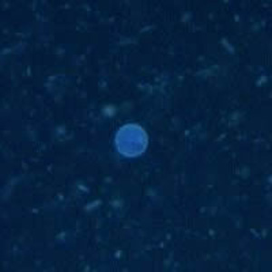

2. Oocyst under UV ultraviolet microscopy: autofluorescence positive, large (25 to 30 µm), typical ellipsoidal shape
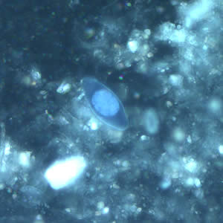 | 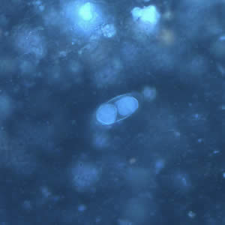

Part B: Wet Preps

3. wet mount, stained with iodine.

4. wet mount, unstained.

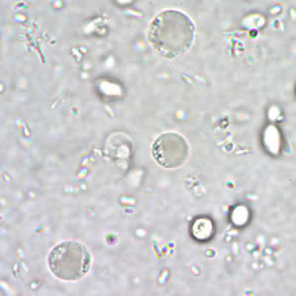 | 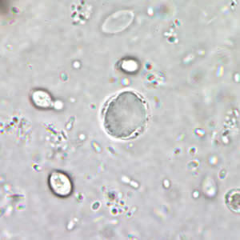

5. concentrated wet mount stained with iodine, 35 µm
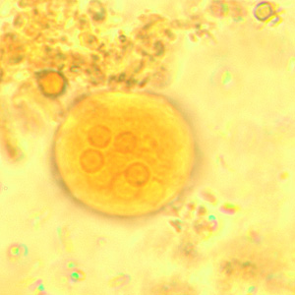 | 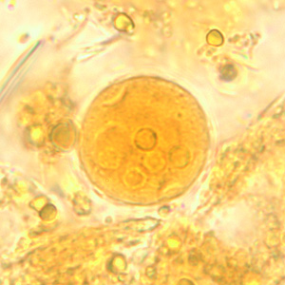

6. unstained wet mount, 30 µm by 15 µm.
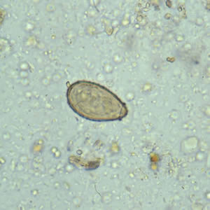 | 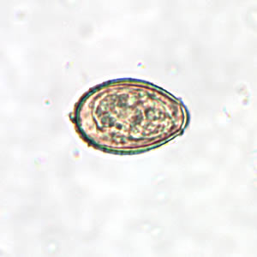

7. wet mount

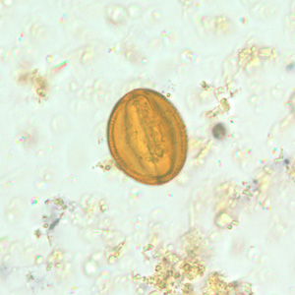 | 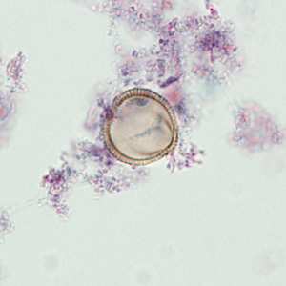

8. wet prep, 65 µm
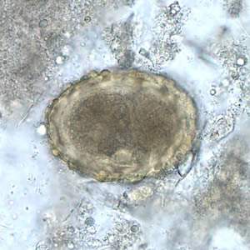 | 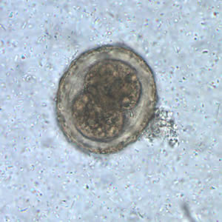

Part C: Modified Acid Fast for Cryptosporidium and Cyclospora
9. modified acid fast stain, 10 µm
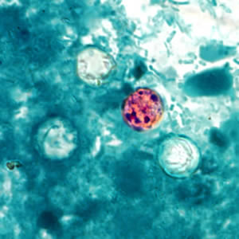 | 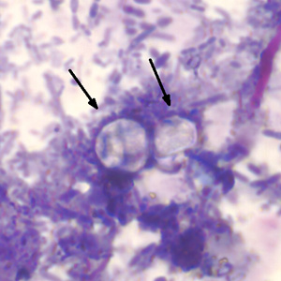

10. modified acid fast stain, 5 µm
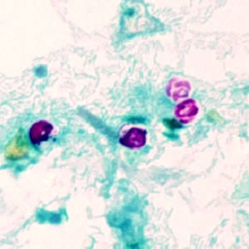 | 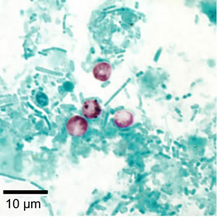

Specimen ID | Result
1 | Negative for Cyclospora and Isospora  Positive for Cyclospora, Negative for Isospora  Positive for Isospora, Negative for Cyclospora
2 | Negative for Cyclospora and Isospora  Positive for Cyclospora, Negative for Isospora  Positive for Isospora, Negative for Cyclospora
3 | Parasite present, identified as ___________________________  This parasite is considered to be non pathogenic but indicates the patient has ingested fecally contaminated food or water. Additional specimens should be submitted for ova and parasite examination.  No ova or parasites detected. (Cryptosporidia. Microsporidia and Cyclospora not routinely tested for.)
4 | Parasite present, identified as ___________________________  This parasite is considered to be non pathogenic but indicates the patient has ingested fecally contaminated food or water. Additional specimens should be submitted for ova and parasite examination.  No ova or parasites detected. (Cryptosporidia. Microsporidia and Cyclospora not routinely tested for.)
5 | Parasite present, identified as ___________________________  This parasite is considered to be non pathogenic but indicates the patient has ingested fecally contaminated food or water. Additional specimens should be submitted for ova and parasite examination.  No ova or parasites detected. (Cryptosporidia. Microsporidia and Cyclospora not routinely tested for.)
6 | Parasite present, identified as ___________________________  This parasite is considered to be non pathogenic but indicates the patient has ingested fecally contaminated food or water. Additional specimens should be submitted for ova and parasite examination.  No ova or parasites detected. (Cryptosporidia. Microsporidia and Cyclospora not routinely tested for.)
7 | Parasite present, identified as ___________________________  This parasite is considered to be non pathogenic but indicates the patient has ingested fecally contaminated food or water. Additional specimens should be submitted for ova and parasite examination.  No ova or parasites detected. (Cryptosporidia. Microsporidia and Cyclospora not routinely tested for.)
8 | Parasite present, identified as ___________________________  This parasite is considered to be non pathogenic but indicates the patient has ingested fecally contaminated food or water. Additional specimens should be submitted for ova and parasite examination.  No ova or parasites detected. (Cryptosporidia. Microsporidia and Cyclospora not routinely tested for.)
9 | Negative for Cryptosporidium, Negative for Cyclospora  Positive for Cryptosporidium, Negative for Cyclospora  Positive for Cyclospora , Negative for Cryptosporidium
10 | Negative for Cryptosporidium, Negative for Cyclospora  Positive for Cryptosporidium, Negative for Cyclospora  Positive for Cyclospora , Negative for Cryptosporidium

Passing: >=80% Score: ◻ Pass ◻ Fail – Corrective Action required

Required Corrective Action for a failed test: Education/retraining and reassessment for any incorrect answers.

Action Taken:

Reassessment Completed: ◻ Pass ◻ Fail Date:

Associate/Caregiver: Date:

Trainer Facilitator: Date:

