Architect

1. Which is FALSE about this QC graph for two levels of Immunoassay Plus for Ferritin:

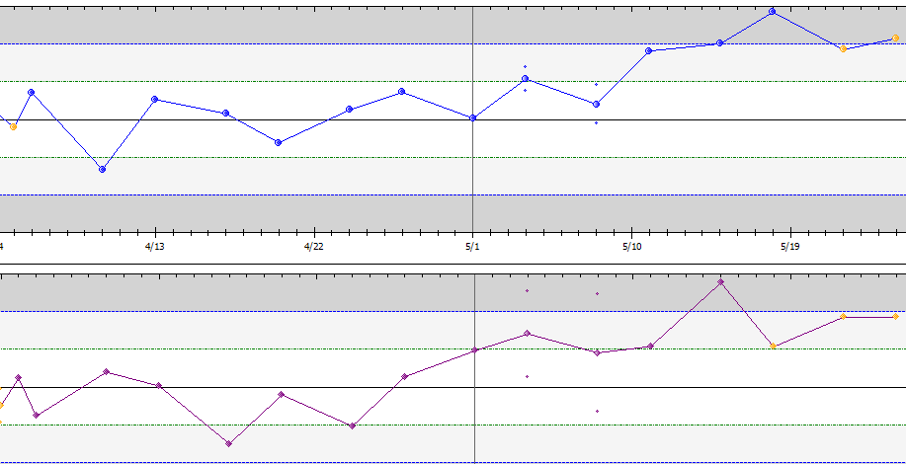

1. If this is the only reagent lot available, it may be time to calibrate.
2. If a new reagent lot was begun 5/4, continue to monitor. Repeat calibration may be indicated to verify mean has changed. Check with coordinator to evaluate.
3. Tiny dots above and below the line indicate interference in Bio-Rad Unity program.
4. Check maintenance logs to make sure required tasks are up to date.
5. In which of the following processing module statuses can the processing center cover be opened?
6. Offline
7. Stopped
8. Warming/Ready
9. All of the above
10. Which statement is TRUE for these tests:
11. There is no dilution for B12 in the policy, so results “>2000.0” should be posted and verified.
12. There is no dilution available for ACCP, so results “>200.0” should be posted and verified.
13. Prolactins should not be run on males since there is no reference range.
14. Reactive HCV must be rerun X2 and evaluated. If 2 of 3 results are non-reactive, report as non-reactive. If 2 of 3 results are reactive, send to reference lab for confirmation.