1. 45 year male admitted to ER complaining of dysuria.

Urinalysis dipstick result : Sp Gravity 1.020, pH 8, Trace Protein, + Nitrite and Leukocyte esterase Urine was cloudy in appearance. Identify the microscopic element designated by the arrow:

1. WBC
2. Transitional Epithelial cell
3. Renal Epithelial Cell
4. Trichomomas

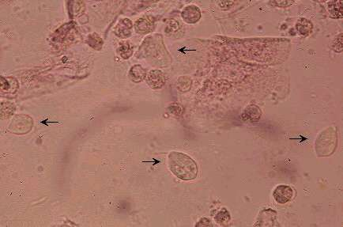

1. A 48 year old female is admitted with edema and high blood pressure who has just recovered from a severe streptococcus infection.

Urine pH 7, + Protein and + blood

Identify elements:

1. RBC
2. Yeast
3. Dysmorphic RBCs
4. Artifact

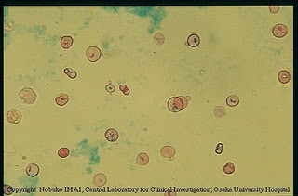 Light microscopy with stain

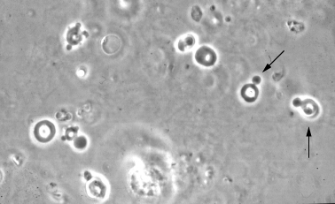 Phase microscopy.

1. A middle –aged woman was admitted to ICU with respiratory failure. During the morning draw her K+ level was a critical at 7.1 mmol/L. However, there was a delta failure because her previous result was 4.1 mmol/L obtained from one day earlier. The specimen is not hemolyzed , it is drawn in a normal Lithium Heparin tube and it was not a line draw specimen. You report out the critical value but the Physician calls back stating that there is no clinical indication for such a K+ change. After further reviewing the patients other laboratory results you find out that this patient has a WBC of 130.2 K/cmm this morning. Her WBC yesterday was 90.2 K/cmm. Not any of her other Chemistry results showed significant change confirming that this is a properly labeled tube. But to be safe you had the patient redrawn STAT and again the Plasma tube was not hemolyzed and the results were similar. So how what the Physician is incident that this result cannot be accurate. Do you have any idea if this is a real K+ result or what would cause a false elevation to be seen?
2. An elderly man was found to be unconscious by his wife and admitted to the E.R. His initial CRP was > 9.0. Upon autodilution of 1:3, the CRP result was 5.5.

His CMET results were:

NA 142

K 4

CL 102

CO2 27

CREA .86

BUN 13

GLU 166

CAL 9.8

TP 4.1

ALB 2.8

TBIL 1.1

ALT 43

ALP 88

AST 34

The CRP dilution was repeated several times with the same result. What is the likely problem and how would you report this result?

1. A 16-day old female infant was admitted to the NURSERY with failure-to-thrive.

Her NBIL results were as follows:

Bili, Unconj. 10.0

Bili; Conj 0.1

Bili, Neonatal 14.4

You verify that these are the answers listed on the Vitros analyzer screen. Is this result correct? Why or why not? How would you proceed?

6)