Fire Drill Awareness Quiz

1. Is this acronym correct? PASS = Pull pin, Aim hose, Squeeze, Sweep base of fire

Yes

No

1. Is this acronym correct? RACE = Rescue, Alarm, Confine, Extinguish

Yes

No

1. Alarm in RACE- Does this mean to call 911 and alert staff to a fire?

Yes

No

1. Hospital Safety suggests staff only use fire extinguishers on small, wastebasket-sized fires. You must feel comfortable operating, otherwise wait for fire dept.

True

False

1. What type of fire extinguishers do we use in the laboratory?
   1. ABC (extinguishes combustibles, flammable, and electrical)
   2. A only
   3. K only (extinguishes fats, grease, and oils)
2. The reading on the gauge of the pictured fire extinguisher is the green area. Does that mean the extinguisher is properly pressurized and ready to use?

True

False

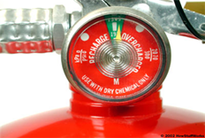

1. Fire extinguishers and fire plan with evacuation routes are in the laboratory.

True

False

1. Do you know where the closest fire extinguisher and pull station is in the area you work?

Yes

No

1. Fire alarm boxes are located by any stairwell.

True

False

1. When do we need to initiate the fire plan?
2. When a patient is missing.
3. When the alarm has sounded.
4. PLMS has a local Emergency Response and Evacuation Plan?

True

False

1. During a fire DRILL you should initiate fire protocol as though the fire is in your area and evacuate horizontally to the opposite side of the hospital, remaining on the same floor.

True

False

1. We do not evacuate vertically unless the fire department or management staff indicates staff to do so.

True

False

1. Individuals with disabilities (i.e. wheelchair, vision impaired) shall be personally assisted by supervisors and Lead Technologists or staff designated by supervisors at the time of emergency, into the next fire zone area.

True

False

1. Our evacuation meeting point is in Bldg 134 by elevators. We will meet here in the event of an emergency that deems our floor unsafe or may require us to exit the building. Here the supervisors will perform a head count of staff.

True

False

1. The assembly location for an **outside** evacuation is
   1. just outside the lab door
   2. one floor below
   3. in horseshoe drive near Main entrance
2. From left to right, the following symbols are a warning for:

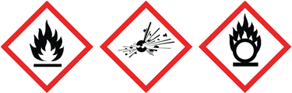

* 1. oxidizer, explosive, flammable
  2. flammable, explosive, oxidizer
  3. flammable, explosive, corrosive
  4. flammable, explosive, flammable