**Pre-Transfusion Testing (Manual Method)**

1. You are performing an ABO/Rh on a patient in tube and get the following results (BB-113-024):

|  |  |  |  |  |
| --- | --- | --- | --- | --- |
| **Anti-A** | **Anti-B** | **Anti-D** | **A cells** | **B cells** |
| 4+ | 0 | 1+ | 0 | 3+ |

How should you proceed?

1. Report the patient as A Positive.
2. Report the patient as A Positive and add an antigen negative requirement for D negative units under Special Instructions and Transfusion Requirements tab.
3. Let the Anti-D incubate at room temperature to increase the reactivity.
4. Perform a saline replacement.
5. You are performing an antibody screen on a patient that has a history of rouleaux. What phase(s) of testing should you perform a saline replacement if you see reactivity? (BB-113-067)
   1. Immediate Spin
   2. 37
   3. AHG
   4. a and b

**Crossmatch**

1. True/False: A patient with a history of Anti-A1 qualifies for electronic crossmatch/immediate spin crossmatch. (BB-113-109)
2. You are performing an AHG crossmatch with enhancement on a patient that gave weakly positive reactions on the antibody screen and panel. What can be done to increase reactivity? (BB-113-112)
   1. Increase the serum-to-cell ratio by adding 3-4 drops of plasma to one drop of donor cells.
   2. Increase the length of incubation to a maximum of 30 minutes.
   3. Look at the reactions microscopically.
   4. All of the above

**Antibody ID, DAT, and Antigen Typing**

1. You are performing antigen typing and get the following results with Anti-Fya: (BB-113-115)

|  |  |  |
| --- | --- | --- |
| Positive Control | Negative Control | Patient |
| W+ | 0 | 0 |

How should you proceed?

* 1. Report the results.
  2. Repeat the positive control with a homozygous cell.
  3. Repeat the positive control with two drops of antisera
  4. Repeat the test with the maximum length of incubation

1. Which of the following cells cannot be used to rule out Anti-D? (BB-113-031)

|  |  |  |  |  |  |  |
| --- | --- | --- | --- | --- | --- | --- |
| **#** | **Donor** | **D** | **C** | **c** | **E** | **e** |
| 1 | R1R1 | + | + | 0 | 0 | + |
| 2 | R2R2 | + | 0 | + | + | 0 |
| 3 | R1r | + | + | + | 0 | + |
| 4 | R1R2 | + | + | + | + | + |

1. 1
2. 2
3. 3
4. 4

**Frozen Component Preparation**

1. True/False: FFP can be converted to 5 day plasma during computer downtime. (BB-113-145)
2. You are modifying a unit of FFP and are about to print the label in HemaTrax. If you print this label, what will happen during label verification? (BB-113-145)

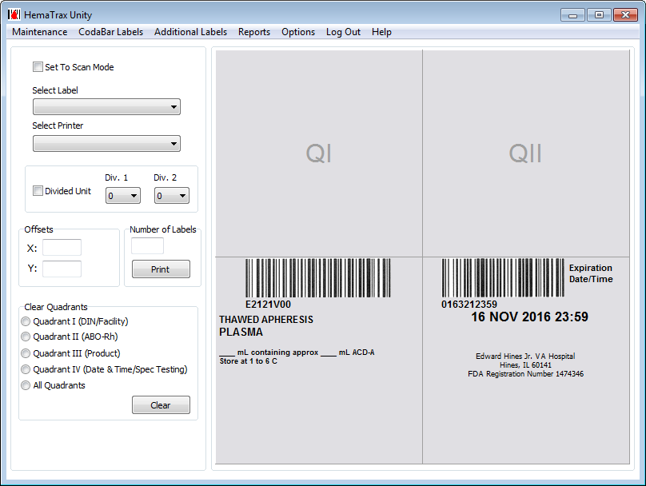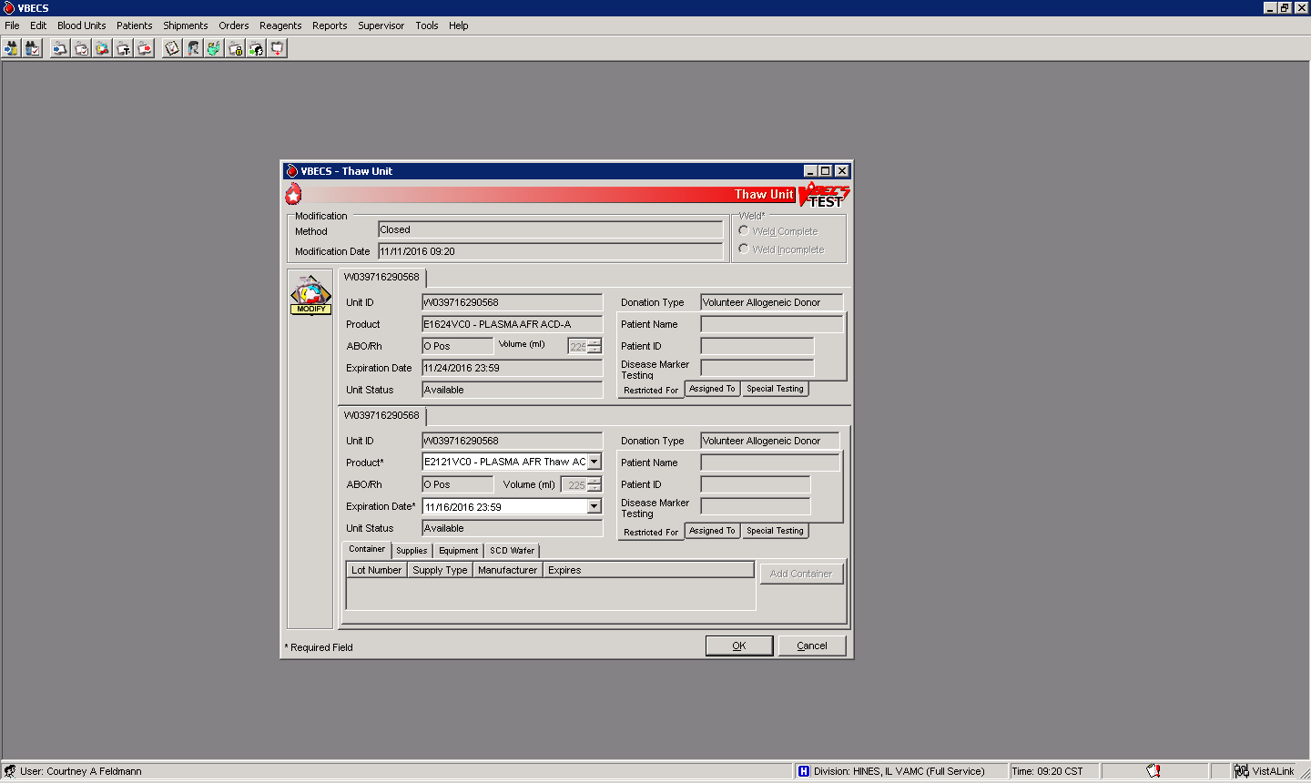

* 1. Label verification will be successful
  2. Label verification will fail because the Product Code does not match
  3. Label verification will fail because the Expiration Date does not match
  4. Label verification will fail because information was not entered into QI or QII

**Issue and Return**

1. True/False: You need to issue a unit of RBCs on a patient that had a bone marrow transplant and the ABO Interpretation was reported as Inconclusive. The unit will show up on the Emergency Issue tab instead of the Assigned Units tab? (BB-113-072)
2. A Nurse returns a unit of RBCs that was issued because the patient spiked a fever. You are a site that does not have a validated method to confirm temperature or took the temperature and it exceeded 10°C. The Nurse states that the MD wants to start the transfusion as soon as the patient is administered Tylenol and estimates she will be ready to start the transfusion in approximately 45 minutes. How should you proceed? (BB-113-127)
   1. Retain the unit in Blood Bank at room temperature until the nurse is ready to transfuse.
   2. Retain the unit in Blood Bank at 1-6°C until the nurse is ready to transfuse.
   3. Discard the unit in VBECS and crossmatch another unit.
   4. Return the unit in VBECS and store at 1-6°C until the nurse is ready to transfuse.

**Galileo Echo Testing**

1. You remove a reagent rack from the Echo and accidently spill a small amount of one of the reagents. How should you proceed? (BB-113-039)
   1. Remove the vial and replace it with a brand new vial.
   2. The software will automatically detect the reduced volume.
   3. Use the software to measure the reduced volume.
   4. Proceed with testing because a small spill does not affect testing
2. The Probe Accuracy Test is used to verify that the dispensing of liquid by the probe does not exceed the acceptable range. How often must it be performed? (BB-113-048)
   1. The Probe Accuracy Test must be performed when a new probe is installed.
   2. The Probe Accuracy Test must be performed when the existing probe is re-seated.
   3. The Probe Accuracy Test is performed by Immucor Field Service during annual PM.
   4. All of the above